*TOR 5: Working Paper: Gulf of Maine haddock WHAM case study*

Charles Perretti

Northeast Fisheries Science Center, NMFS

***GOM haddock assessment history***

Prior to 2002, Gulf of Maine haddock assessments had been conducted by comparing exploitation rates (3-year centered average catch/survey index) to biological reference points generated from a surplus production model (NEFSC 1986, NEFSC 2001). The 2002 assessment compared survey biomass and exploitation rate indices to biological reference points (BRPs) generated by the Working Group on Re-estimation of Biological Reference Points for New England Groundfish (NEFSC 2002).

The stock was assessed again in 2005 as part of GARM II (NEFSC 2005). The same index-based approach used in GARM I was applied in the 2005 assessment. The GARM II review made a research recommendation to explore the use of age-structured models in future assessments. The Gulf of Maine haddock stock was next assessed in 2008 as part of GARM III (NEFSC 2008). An ADAPT-VPA model was applied to the data, and reference points were based on a yield and spawning biomass per recruit analysis, with F40% selected as the fishing mortality reference point (FMSY-proxy).

A benchmark assessment for Gulf of Maine haddock occurred in 2014 (NEFSC 2014) using data through 2013. The assessment model was changed from the VPA to a statistical catch-at-age model, the Age-Structured Assessment Program (ASAP). Based on the results of the 2014 update, the Gulf of Maine haddock stock was declared not overfished, and overfishing was not occurring.

Assessment updates to that model occurred in 2015 (NEFSC 2015), 2017 (NEFSC 2017) and 2019 (NEFSC 2019) using the 2014 benchmark assessment model. In all updates, the Gulf of Maine Haddock stock was declared not overfished and overfishing was not occurring. Retrospective errors were considered minor in 2015 and 2017, therefore no retrospective adjustment was performed. The stock experienced several strong recruitment events, particularly in 2012 and 2013, and this resulted in a time series high SSB in the 2017 and 2019 updates. In 2019, the retrospective error was considered major, and the retrospective adjustment resulted in a large increase in estimated historical biomass.

The most recent benchmark (now known as a Research Track assessment) concluded in 2022 using data through 2019, with ASAP selected as the final model platform, but with a research recommendation to explore a state-space assessment model in the upcoming State-Space Research Track Assessment (NEFSC *In Prep*). Overall, the ASAP model performed well and was therefore retained, however retrospective error was considered moderate, and a research recommendation from the review panel.

The most recent assessment update occurred in 2022 using data through 2021. The stock was declared not overfished but overfishing was occurring. Notably, the retrospective error increased to major, which means it required a retrospective adjustment, and reversed its direction in this assessment causing a substantial reduction in estimated historical biomass. Reducing the retrospective error, and improving the fit to the survey indices in the final decade (more on that below) are the main goals of this proposed switch to the Woods Hole Assessment Model (WHAM).

***Data inputs***

A full description of the data inputs in the GOM haddock assessment model is provided in NEFSC *In Prep*. Briefly, the assessment incorporates the spring and fall NMFS Bottom Trawl Survey (BTS) (Figures 1 & 2). There was a strong 1963 year class that is apparent in both the fall and spring surveys as well as several moderate recruitment events during the mid-1970s. The period from the mid-1980s to the mid-1990s was characterized by poor recruitment. A strong year class was spawned in 1998, followed by a moderate year class in 2003. A very strong year class was spawned in 2013 that tracks well in both the spring and fall surveys in recent years.

There is both a commercial and recreational fishery for GOM haddock (Figure 3). The commercial fishery was dominant until the early 2000’s, after which the recreational component has become more important. The commercial fishery is dominated by landings with a relatively minor amount of discards. The recreational fishery was initially dominated by landings, but the proportion of discards has increased in recent years due to regulatory changes. The assessment model combines both fisheries into a single fleet, and the combined age-composition shows similar strong year-classes as the surveys (Figure 4).

Maturity and the length-weight equation are estimated using the survey data as time-invariant relationships given the lack of trend in both (NEFSC *In Prep*). Natural mortality is assumed equal to 0.2, and spawning stock biomass weight-at-age is estimated using the Rivard calculation applied to the combined fishery weight-at-age (Rivard 1982).

***Current assessment model***

The current stock assessment model for GOM haddock was originally developed in SAW/SARC59 (NEFSC 2014), and updated in subsequent operational stock assessments (NEFSC 2015, NEFSC 2017, NEFSC 2019), further refined in the 2022 Research Track Assessment (NEFSC *In Prep*), and updated in the most recent management track assessment (NEFSC 2022). It is the statistical catch-at-age model, ASAP (Age Structured Assessment Program v3.0.17, Legault and Restrepo 1998), which can be obtained from the NOAA Fisheries Toolbox (https://nmfs-fish-tools.github.io/). Catch-at-age and survey age composition are modeled assuming a multinomial distribution, while most other model components are assumed to have lognormal error. Specifically, lognormal error is assumed for total catch in weight by fleet, survey indices, and annual deviations in fishing mortality. Recruitment deviations are also assumed to follow a lognormal distribution, with annual deviations estimated as a bounded vector to force them to sum to zero. For more technical details, please see Legault 2012.

The ASAP model allows recruitment deviations to be constrained by applying a penalty on the deviations. However, for GOM haddock, no penalty is applied. The CVs on the recruitment deviations are set to 1 for all years. The terminal year effective sample size (ESS) for the fishery was set at 140, and 25 and 12 for the NEFSC spring and fall surveys, respectively. CVs on the total catch were set at 0.2 for the period prior to observer coverage (1977-1988), 0.15 for the period prior to the increase in the recreational catch component (1989 - 2000) and at 0.10 for the remainder of the catch time series (2001-2021). The bootstrapped CVs characterize the sampling, or observation error, but additional variability may be present in the survey indices that are not reflected in the bootstrapped CVs. Following the SAW/SARC59 results, the CVs were increased by 0.3 in the spring, and 0.2 in the fall, to account for additional variability in the surveys.

Fishery catches were modeled as a single fleet, with both commercial and recreational fleets combined. Three different fishery selectivity blocks were applied (1977-1988, 1989-2004, 2005-2021). The 1988/1989 split corresponds to the start of the at-sea observer program and the direct observation of fishery discards and length frequency information (though length sampling was sparse in the early years). Beginning around 1992, the magnitude of recreational catch began to increase. The 2004/2005 split corresponds to a drop in the recreational minimum size from 23” to 19” between 2002 and 2004, and a reduction in commercial minimum size in 2007 from 19’’ to 18’’, with further reductions to 16’’ in July 2013.

The current assessment model estimates fishery selectivity as flat-topped in the first (1977-1988) and second (1989-2004) selectivity blocks, with a slight dome in the third block (2005-2021) (Figure 5). The doming in the final block is thought to reflect the increasing contribution of the recreational fishery in recent years.

Although the model diagnostics have been considered good overall, it has struggled to fit the rapid rise and fall in the observed survey indices in the last decade (Figure 6). In particular, the high abundance years immediately following the 2013 year class, as well as the most recent decline in abundance as that year class has aged. Similarly, the model developed a major retrospective pattern in the 2019 update due to the rapid increase in SSB implied by the survey observations. In the most recent update, a moderate retrospective pattern has developed in the opposite direction as SSB has declined rapidly (NEFSC 2022). Possible drivers of these diagnostic problems include movement across stock boundaries, time-varying natural mortality, catch estimation errors, or some combination of the three. Previous work has not provided a definitive answer on the relative importance of each driver.

***Model configurations explored***

An exploration of WHAM was performed with the goal of improving the fit to the aggregate survey index in the terminal decade, as well as reducing the retrospective pattern. Specifically, random effects in numbers-at-age were introduced, under the hypothesis that it would increase model flexibility. Given that the source of the diagnostic problems is unknown, including random effects in numbers-at-age was preferred as it is mechanism-agnostic, as opposed to, for example, including random effects in M and asserting that time-varying natural mortality is the driver of the diagnostic problems.

An initial ASAP-like WHAM model was explored to bridge from ASAP to WHAM. The ASAP-like model was configured to be as similar as possible to the accepted GOM haddock ASAP model. After that, three models were tested that included 2d-ar1 random effects in numbers-at-age. Each model differed in the age-composition likelihood: (1) multinomial, (2) Dirichlet, (3) logistic-normal. Additional diagnostic plots and R code used to fit the models can be found at https://github.com/NEFSC/READ-PDB-PERRETTI_HADSSRT.

Model selection followed a similar process to that of the recent Atlantic cod Research Track Assessment (NEFSC *In Prep*), with the following diagnostics examined for each model:

1. **Convergence:** Initial model acceptance focused on the requirement that the model converge on a solution. Models passed first order convergence criteria when the maximum gradient of the negative log-likehood function was less than a software-specific threshold. They met the second order convergence criterion when the Hessian matrix was invertible.
2. **Residuals:** Goodness of fit was examined through residual analyses, including examination of joint residual plots and examination for non-random residual patterns. One-step ahead (OSA) residuals were also used to judge model fit for WHAM. OSA residuals should be uncorrelated and normally distributed for models that appropriately describe the system.
3. **Akaike’s Information Criteria**: AIC was used to compare candidate models fit to the same data and therefore had comparable likelihoods. Smaller AIC scores indicated model improvement when data inputs are identical, and scores within +/-2 were considered equivalent across comparable models, in which case the more parsimonious of the models is preferred.
4. **Retrospective patterns:** Retrospective error was evaluated for all candidate models and measured using seven-year Mohn’s rho for spawning stock biomass and fully selected fishing mortality.
5. **Prediction skill:** Prediction skill was evaluated for candidate models using error of forecast values as measured by mean absolute scaled error (MASE). A 20-year peel was used, with prediction error calculated over one- to five-year time horizons. First-order model convergence was also calculated for each peel. A MASE below 1 indicates predictive skill that is better than a naïve approach of predicting future observations to be equal to the terminal observation of the peel.
6. **Estimation performance:** Estimation performance was evaluated using simulation self-tests for candidate models. Each fitted model was used to generate up to 100 datasets with parameters fixed at their estimated values. Only observation errors were simulated in order to retain the historical trajectory of the stock. Simulations then refit the model to these generated datasets to evaluate relative error in F, SSB, R and model convergence rates.

*ASAP-like model*

Convergence and an invertible hessian were achieved once population abundance initial year values for ages seven and eight were fixed to their starting values. Fleet selectivity estimates were similar to the ASAP model (Figure 7), and age-composition residuals showed relatively minor patterning (Figures 8 & 9).

Although the fit to the aggregate fishery catch was similar to the ASAP model, the fit to the survey time series was substantially worse in the terminal year of the WHAM ASAP-like model (Figure 10). The ASAP model fits the terminal observation within the 90% confidence interval, however the WHAM ASAP-like model has a large residual in the terminal year. This residual is the largest in the time series for the spring survey, and the second largest in the time series for the fall survey.

In addition to the large terminal residuals in the survey indices, the ASAP-like model had a worse retrospective error in recruitment compared to the ASAP model (Table 1). The increase in retrospective error was driven by a large overestimate of the 2019 year class strength when the terminal year is 2020 (Figure 11). This also resulted in poor prediction accuracy in the terminal year, as shown in Figure 12.

*Numbers-at-age random effects models*

As mentioned previously, three numbers-at-age random effect models were tested, each of which differed only in the age-composition likelihood used. They are labeled RE multinomial, RE Dirichlet, and RE logistic-normal.

AIC values are only comparable across models that use the same data inputs. The Dirichlet and logistic-normal use proportion-at-age, while the multinomial uses numbers-at-age, therefore their AICs are not comparable. However, the ASAP-like model and the RE multinomial model are comparable since both use numbers-at-age, and the Dirichlet and logistic-normal are comparable because both use proportions-at-age. The WHAM-like model had a lower AIC than the RE multinomial model, and the RE logistic-normal model had a lower AIC than the RE Dirichlet model (Table 1).

Despite the differences in AIC, visual inspection of diagnostics reveals only minor differences in model fit between the RE models. The most notable difference was between the ASAP-like model and all of the RE models, where the RE models better fit the terminal index observation in both surveys (Figure 13). All models closely fit the aggregate fleet catch time series (Figure 14).

Survey age-composition residuals were similar between all models, with slightly lower age-1 residuals in the Dirichlet model (Figures 15 & 16), and fleet age-composition residuals were lowest in the Dirichlet model (Figure 17). Survey age-composition OSA residuals were similar across models, but with reduced residuals in 1994 in the Dirichlet and logistic-normal models (Figures 18 & 19). Fleet age-composition OSA residuals were similar across models (Figure 20).

Retrospective error for SSB and *F* was lower in all WHAM models than the ASAP model (Table 1). Retrospective error for SSB was lowest in the RE multinomial model, and for *F* it was lowest in the RE Dirichlet model. None of the WHAM models would require a retrospective adjustment if this were a Management Track assessment (i.e., the retro-adjusted SSB and *F* values did not fall outside of their 90% confidence intervals).

Prediction error for each model is summarized in Table 2. Overall, prediction error was similar across models, and all models had lower error for the spring survey than the fall survey. For the spring survey, prediction error for all models was lower than the naive method of predicting the future to be equal to the terminal observation (i.e., MASE < 1). For the fall survey, prediction error was slightly lower than the naive method for the ASAP-like model, slightly higher than the naive method for the RE multinomial and RE Dirichlet models, and substantially higher than the naive method for the RE logistic-normal model.

Although MASE scores were similar, plots of the predictions from each model show clear differences in the patterns of error (Figures 12 & 21 - 23). As mentioned previously, the ASAP-like model had large errors in the terminal year due to an overestimate of the 2019 year class recruitment in 2020 (Figure 12). The RE logistic-normal model suffered a similar overestimate of recruitment and subsequent over-prediction of survey abundance in the terminal year (Figure 21). In contrast, the RE multinomial (Figure 22) and RE Dirichlet (Figure 23) both correctly predict the decline in abundance in the terminal five years.

In simulation self-tests, all models had high convergence rates, however estimation error varied across models (Table 3). The ASAP-like model had the lowest average error in all measured variables at 1%. All of the RE models had substantially higher error than the ASAP-like model, with the highest error found in the RE logistic-normal model (26%) and the lowest error in the RE Dirichlet model (13%). The pattern of bias was similar in the RE models with all underestimating SSB in the last decade and overestimating *F* in the 1980s (Figures 24 - 27). Of the RE runs, only the Dirichlet model captured the true values within the 90% confidence interval of the mean fit for all variables.

*Proposed final model: RE Dirichlet model*

All models with random effects appear to be an improvement over the ASAP-like model, particularly due to their improved fit to the survey indices. Of the RE models, I recommend the RE Dirichlet model as the final model to replace the current ASAP model.

There are four main reasons that the RE Dirichlet model is preferable to the current ASAP model: First, the RE Dirichlet model has an improved fit to the survey time series, particularly in the final decade (compare Figure 13 vs. Figure 10). Second, the RE Dirichlet model has substantially lower retrospective error in SSB (0.30 vs. 0.16) and *F* (-0.25 vs. -0.06). Retrospective error on recruitment is higher in the RE Dirichlet model, however recruitment retrospective error is typically highly variable, and in this case is heavily influenced by a single outlier estimate in 2020. Third, the RE Dirichlet model was one of only two WHAM models that correctly predicted the direction of change in the survey indices in the final decade (Figures 12 & 21 - 23). Fourth, it had the lowest self-simulation error of all random effect models (Table 3).

***Comparison of results: Current ASAP model vs. RE Dirichlet model***

As mentioned previously, the RE Dirichlet model shows improved fit to the survey indices, and similar fit to the aggregate catch. Age-composition residuals are generally small and lack problematic patterning for both models (Figure 8 vs Figure 28).

Index selectivity estimates were similar between the current ASAP model and the RE Dirichlet model (Figure 29), with full selectivity occurring at age-4 in the spring survey and age-5 in the fall survey in both models. Fleet selectivity estimates were somewhat different, with the RE Dirichlet model having higher selectivity at young ages and decreasing selectivity at older ages in the first two selectivity blocks, while the ASAP model had lower selectivity at young ages in the first two blocks and decreasing selectivity at older ages in the third selectivity block only.

Survey catchability estimates were lower for both surveys in the RE Dirichlet model compared to the ASAP model (Table 4). However, catchability differences between seasons were similar in each model, with catchability being approximately 2.3 times higher in the fall than spring in the RE Dirichlet model, and 2.9 times higher in the fall than spring in the ASAP model.

The NAA random effect estimates for the RE Dirichlet model are shown in Figure 30. Random effects are strongest in age-1 (recruits), with clear correlation both over time and across ages. Recruitment random effects were negative in the late 1980’s and early 1990’s, and have been positive since the early 2010’s, with the strongest positive effect associated with the 2013 year class. Ages 2+ random effects are generally similar across ages, with positive random effects in the late 1990’s and 2010’s, and negative effects in the most recent five years.

A comparison of SSB, F, and recruitment are shown in Figure 31, including the 2022 Management Track model estimates (NEFSC 2022). Overall, trends in SSB, F, and recruitment are similar in all models, but SSB is highest in the RE Dirichlet model, most likely due to the lower survey catchability estimates mentioned previously. Correspondingly, fishing mortality is generally lower in the RE Dirichlet model than the previous ASAP models. SSB peaks in 2017 in both models, however the peak biomass is over four times higher in the RE Dirichlet model, illustrating the greater flexibility of that model compared to the ASAP model. This elevated level of SSB in 2017 is seen in all RE models (Figure 32), indicating that it is due to the inclusion of NAA RE. Recruitment differences between the two models varied by year, with the RE Dirichlet model estimating higher recruitment on average than the ASAP models.

A comparison of reference point estimates are given in Table 5 and shown with the time series estimates for each model in Figure 33. *Fmsy* is slightly lower for the RE Dirichlet model at 0.26 compared to the ASAP model at 0.34, and *Bmsy* is higher for the RE Dirichlet model at 16,642 mt compared to the ASAP model at 6,123 mt. *F* in the terminal year of the RE Dirichlet model is 0.25, which is just below the overfishing threshold of 0.26. *SSB* in the terminal year is 21,318 mt which is above the overfished threshold of 8,321 mt.

A comparison of catch and SSB projections is shown in Table 6. For ease of comparison, the RE Dirichlet model uses the same projected WAA and the same assumed 2022 catch as the ASAP model. Both models project an initial increase in SSB in 2023, followed by a decline in 2025. Overall, SSB and catch projections are slightly lower for the RE Dirichlet model compared to the ASAP model.

***Summary***

A Woods Hole Assessment Model (WHAM) for GOM haddock was developed, with the main goal of reducing the retrospective error found in the most recent assessment and improving the fit to the survey indices in the terminal decade. The ASAP-like WHAM had large residuals in the indices in the terminal year, high retrospective error for recruitment, and inaccurate predictions in the terminal year. Therefore, three additional WHAMs were explored, all of which allowed for 2dar1 random effects (RE) on all ages. Model fit was generally similar across the RE WHAMs, with generally good diagnostics, an improved fit to the terminal decade of the indices compared to the ASAP model, and lower retrospective error than the ASAP model. The RE Dirichlet model was the only model to correctly predict the direction of change in the survey indices, and had the lowest simulation error of all RE models. Therefore, I recommend the RE Dirichlet model as the final model for GOM haddock.

Trends in SSB, F, and recruitment are similar between the RE Dirichlet model and the accepted ASAP model, with generally lower *F* and higher SSB in the RE Dirichlet model. The overfishing reference point is similar between the two models with RE Dirichlet having a slightly lower F*msy*. SSB*msy* is higher in the RE Dirichlet model due to the higher scale of recruitment throughout the timeseries. Projections are similar overall, with slightly lower projections in the RE Dirichlet model in the immediate future.

***References***

Legault CM. 2012. Technical Documentation for ASAP Version 3.0 NOAA Fisheries Toolbox (https://noaa-fisheries-integrated-toolbox.github.io/).

NEFSC (Northeast Fisheries Science Center). 1986. Report of the Second NEFC Stock Assessment Workshop (Second SAW). NMFS, NEFSC, Woods Hole Laboratory Reference Document. 86-09.

NEFSC (Northeast Fisheries Science Center). 2001. Report of the 32nd Northeast Regional Stock Assessment Workshop (32nd SAW): Stock Assessment Review Committee (SARC) consensus summary of assessments. NMFS NEFSC Ref. Doc. 01-05. 300 p.

NEFSC (Northeast Fisheries Science Center). 2002. Final report of the Working Group on re-evaluation of biological reference points for New England groundfish. NMFS NEFSC Ref. Doc. 02-04. 123 p.

NEFSC (Northeast Fisheries Science Center). 2005. Assessment of 19 Northeast groundfish stocks through 2004. 2005 Groundfish Assessment Review Meeting (2005 GARM), Northeast Fisheries Science Center, Woods Hole, Massachusetts. August 15-19, 2005. NMFS NEFSC Ref. Doc. 05-13. 508 p.

NEFSC (Northeast Fisheries Science Center). 2008. Assessment of 19 Northeast groundfish stocks through 2007. Report of the 3rd Groundfish Assessment Review Meeting (GARM III), Northeast Fisheries Science Center, Woods Hole, Massachusetts. August 4-8, 2005. NMFS NEFSC Ref. Doc. 08-15. 884 p.

NEFSC (Northeast Fisheries Science Center). 2014. 59th Northeast Regional Stock Assessment Workshop (59th SAW) assessment report, Northeast Fisheries Science Center, Woods Hole, Massachusetts. July 15-18, 2014. NMFS NEFSC Ref. Doc. 14-09. 786 p.

NEFSC (Northeast Fisheries Science Center) 2015. Operational Assessment of 20 Northeast Groundfish Stocks, Updated through 2014, Northeast Fisheries Science Center, Woods Hole, Massachusetts. NMFS NEFSC Ref. Doc. 15-24. 256 p.

NEFSC (Northeast Fisheries Science Center) 2017. Operational assessment of 19 northeast

groundfish stocks, updated through 2016, Northeast Fisheries Science Center, Woods Hole,

Massachusetts. NMFS NEFSC Ref. Doc. 17-17. 264 p.

NEFSC (Northeast Fisheries Science Center). 2019. Operational Assessment of 14

Northeast Groundfish Stocks, Updated Through 2018. US Dept Commer, Northeast Fish Sci Cent

Ref Doc.

NEFSC (Northeast Fisheries Science Center). 2022. Management Track Assessments Fall 2022. NMFS NEFSC Tech. Memo. 305. https://doi.org/10.25923/380j-t283

NEFSC (Northeast Fisheries Science Center). *In Prep*. Summary report of the Gulf of Maine haddock research track stock assessment. NMFS NEFSC Ref. Doc. XX-XX. XXX p.

NEFSC (Northeast Fisheries Science Center). *In Prep*. Summary report of the Atlantic cod research track stock assessment. NMFS NEFSC Ref. Doc. XX-XX. XXX p.

Rivard D. 1982. APL programs for stock assessment (revised). Can. Tech. Rep. Fish. Aquat. Sci. 1091. 146 p.

***Tables***

Table 1. AIC and retrospective error for all models. Retrospective error is quantified by the seven-year Mohn’s Rho.

|  |  |  |  |  |
| --- | --- | --- | --- | --- |
| **Model** | **AIC** | **R rho** | **SSB rho** | **F rho** |
| ASAP (2022 Management Track) | NA | -0.10 | 0.30 | -0.25 |
| WHAM ASAP-like | 3341.9 | 6.93 | 0.16 | -0.13 |
| WHAM Re Multinomial | 3356.9 | 0.94 | -0.002 | 0.09 |
| WHAM RE Logistic-Normal | -2889.3 | 1.38 | -0.06 | 0.24 |
| WHAM RE Dirichlet | -2850.8 | 0.67 | 0.16 | -0.06 |

Table 2. Prediction error for all models. Prediction error is quantified as the Mean Absolute Scaled Error (MASE) of predicted versus observed aggregate survey catch using a 20-year peel and predicting one to five years ahead.

|  |  |  |  |
| --- | --- | --- | --- |
| **Model** | **NMFS BTS Spring** | **NMFS BTS Fall** | **Convergence rate over all peels** |
| ASAP (2022 Management Track) | NA | NA | NA |
| WHAM ASAP-like | 0.82 | 0.87 | 100% |
| WHAM Re Multinomial | 0.79 | 0.94 | 100% |
| WHAM RE Logistic-Normal | 0.84 | 1.15 | 100% |
| WHAM RE Dirichlet | 0.78 | 0.96 | 100% |

Table 3. Self-simulation bias as quantified by the mean percent difference between the true and estimated values over all years in 100 replicates [(estimated - true)/true * 100].

|  |  |  |  |  |
| --- | --- | --- | --- | --- |
| **Model** | **R mean bias** | **SSB mean bias** | **F mean bias** | **Convergence rate** |
| WHAM ASAP-like | 1% | 1% | 1% | 99% |
| WHAM Re Multinomial | -17% | -20% | 36% | 100% |
| WHAM RE Logistic-Normal | -16% | -22% | 39% | 95% |
| WHAM RE Dirichlet | -11% | -10% | 18% | 100% |

Table 4. Catchability estimates from the accepted ASAP model and the proposed final RE Dirichlet model.

|  |  |  |
| --- | --- | --- |
| **Model** | **Spring NMFS BTS** | **Fall NMFS BTS** |
| ASAP | 0.29 | 0.84 |
| WHAM RE Dirichlet | 0.16 | 0.37 |

Table 5. Reference point estimates and terminal year values from the accepted ASAP model and the RE Dirichlet model.

|  |  |  |  |  |
| --- | --- | --- | --- | --- |
| **Model** | **Fmsy** | **F2021** | **SSBmsy** | **SSB2021** |
| ASAP | 0.34 | 0.38 | 6,123 | 16,528 |
| WHAM RE Dirichlet | 0.26 | 0.25 | 16,642 | 21,318 |

Table 6. Projected catch at Fmsy and projected SSB from the accepted ASAP model and the WHAM RE Dirichlet model.

|  |  |  |  |  |  |
| --- | --- | --- | --- | --- | --- |
| **Year** | **Input** | **Catch (mt) - ASAP** | **Catch (mt) - WHAM** | **SSB (mt) - ASAP** | **SSB (mt) - WHAM** |
| 2021 | Model result | 4,602 | 4,602 | 16,528 | 21,318 |
| 2022 | Assumed catch | 3,912 | 3,912 | 14,920 | 14,200 |
| 2023 | Fmsy | 2,515 | 2,154 | 16,002 | 14,393 |
| 2024 | Fmsy | 2,552 | 2,262 | 15,400 | 14,421 |
| 2025 | Fmsy | 2,434 | 2,140 | 13,189 | 12,604 |

***Figures***

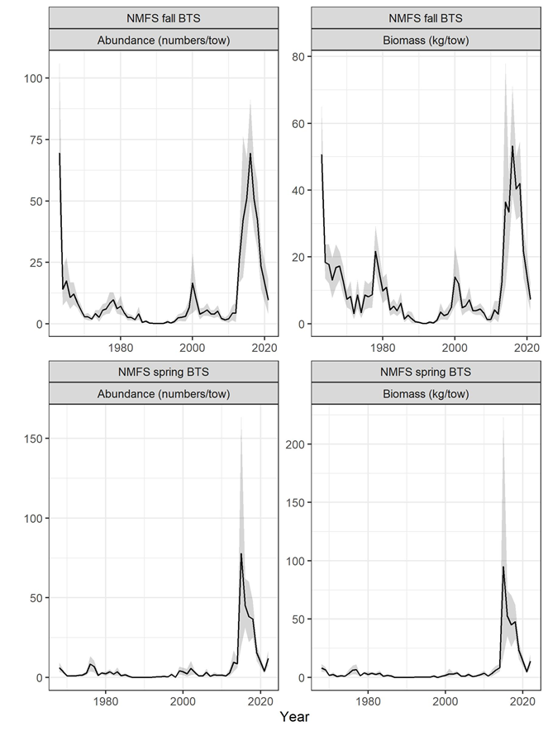

Figure 1. NMFS Bottom Trawl Survey (BTS) aggregate indices of abundance (left) and biomass (right) in the fall (top) and spring (bottom) surveys.

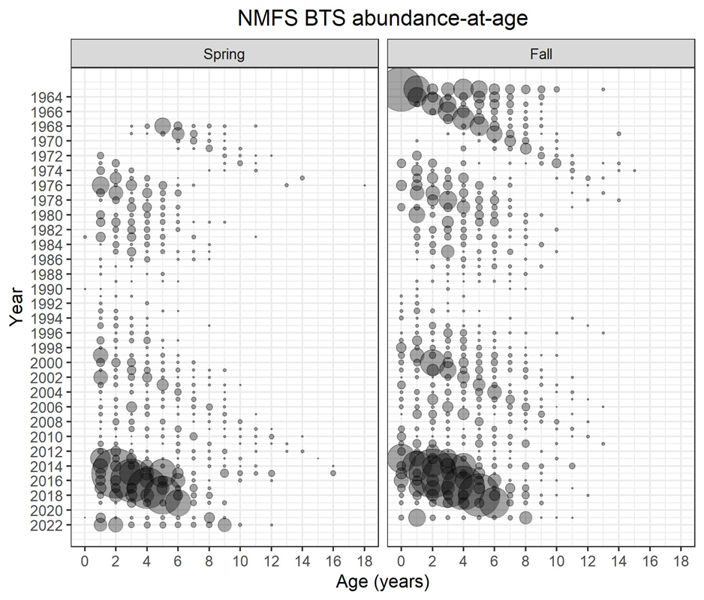

Figure 2. NMFS Bottom Trawl Survey (BTS) numbers-at-age for the spring (left) and fall (right) surveys.

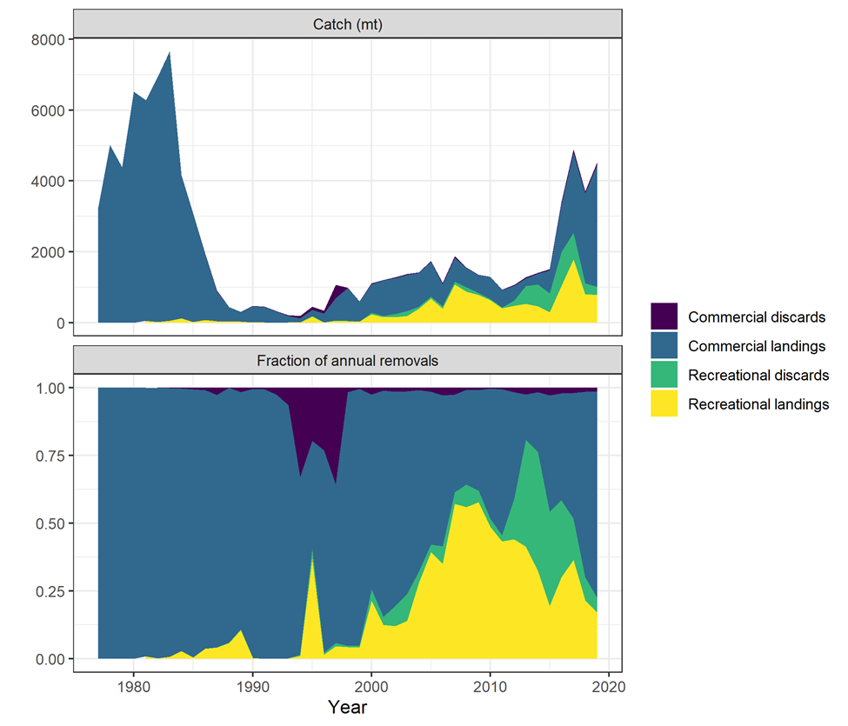

Figure 3. Total catch (top) and proportion of catch (bottom) of GOM haddock by source.

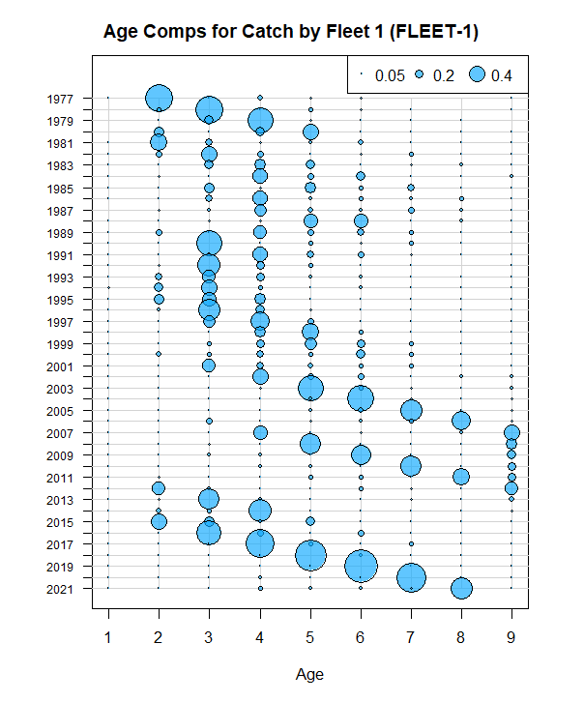

Figure 4. Combined fishery catch proportion-at-age.

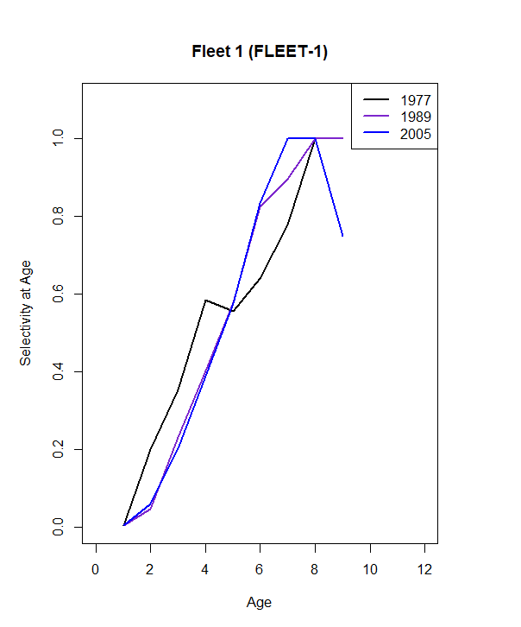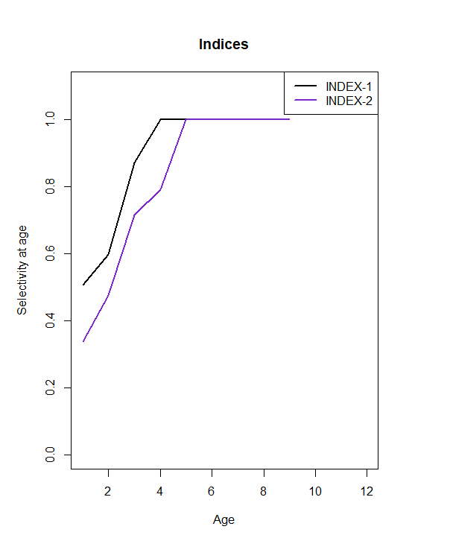

Figure 5. Selectivity estimates from the 2022 GOM haddock ASAP model (NEFSC 2022). Fleet 1 is the combined fishery fleet, Index 1 is the NMFS spring survey, and Index 2 is the NMFS fall survey.

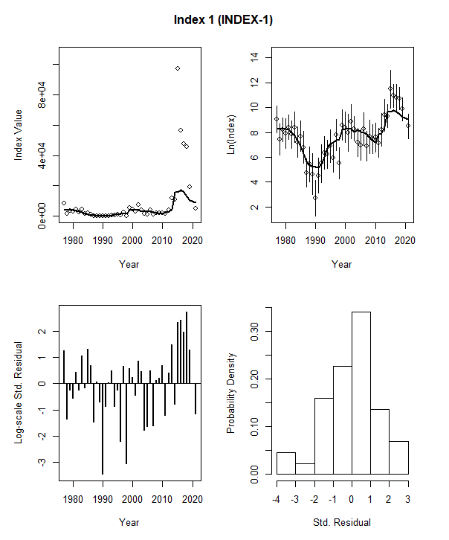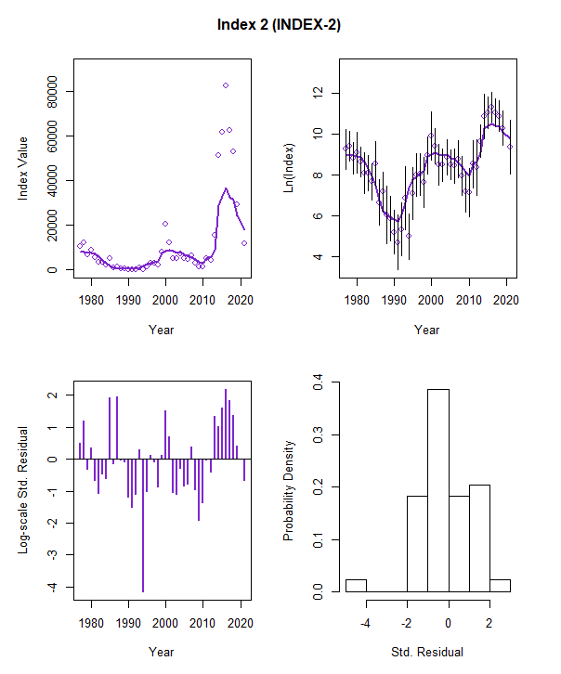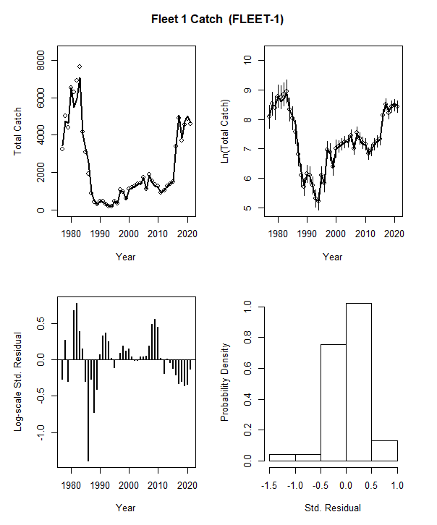

Figure 6. Aggregate index fit and aggregate catch fit for the 2022 GOM haddock ASAP model.

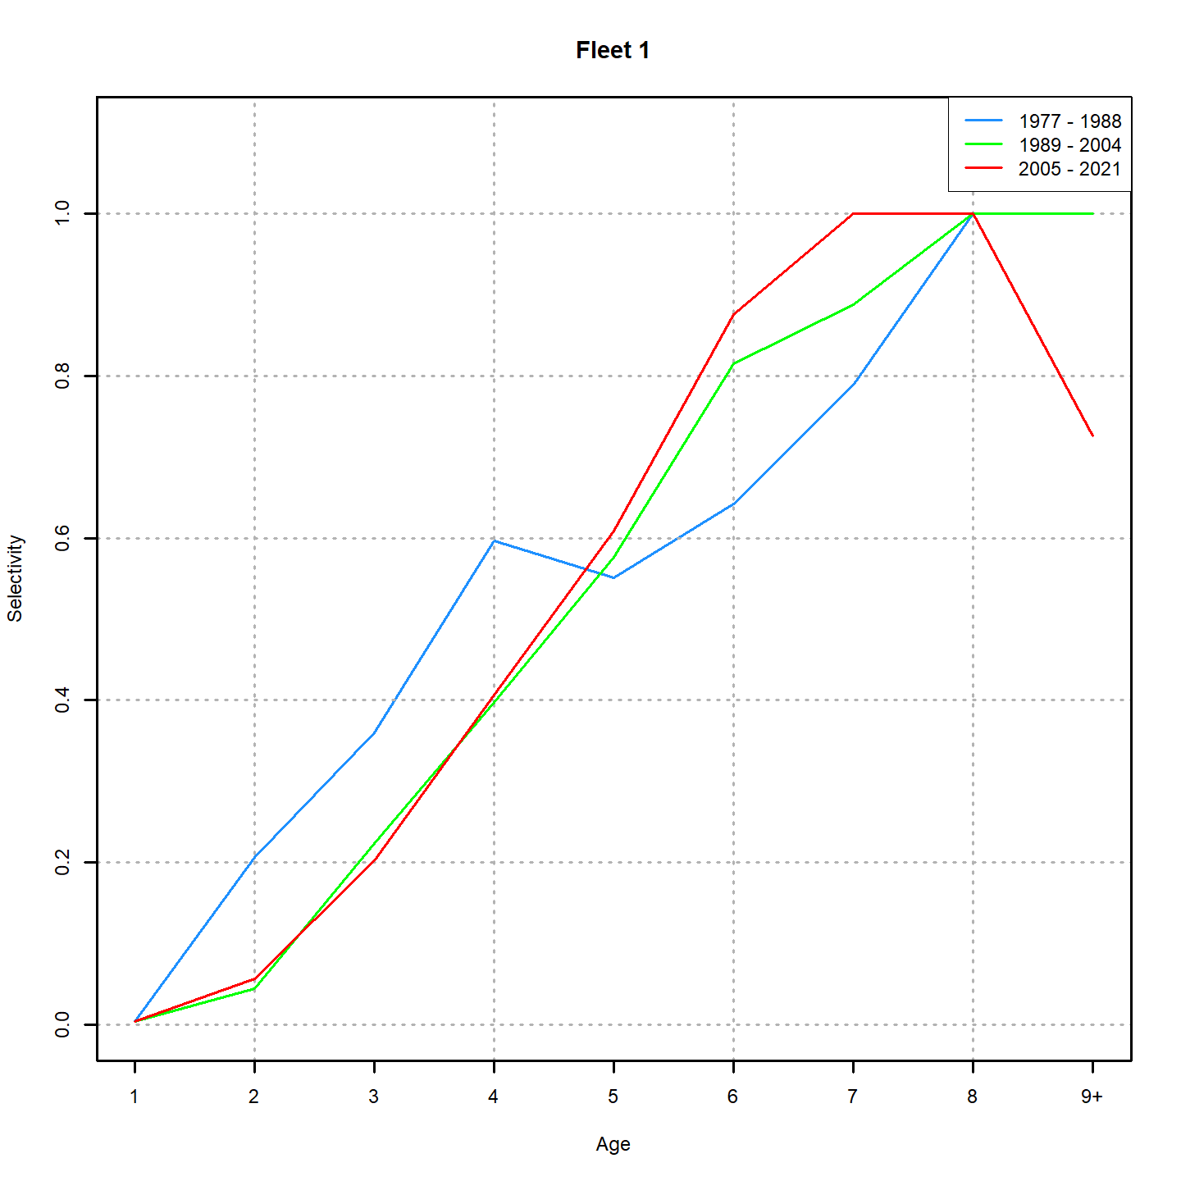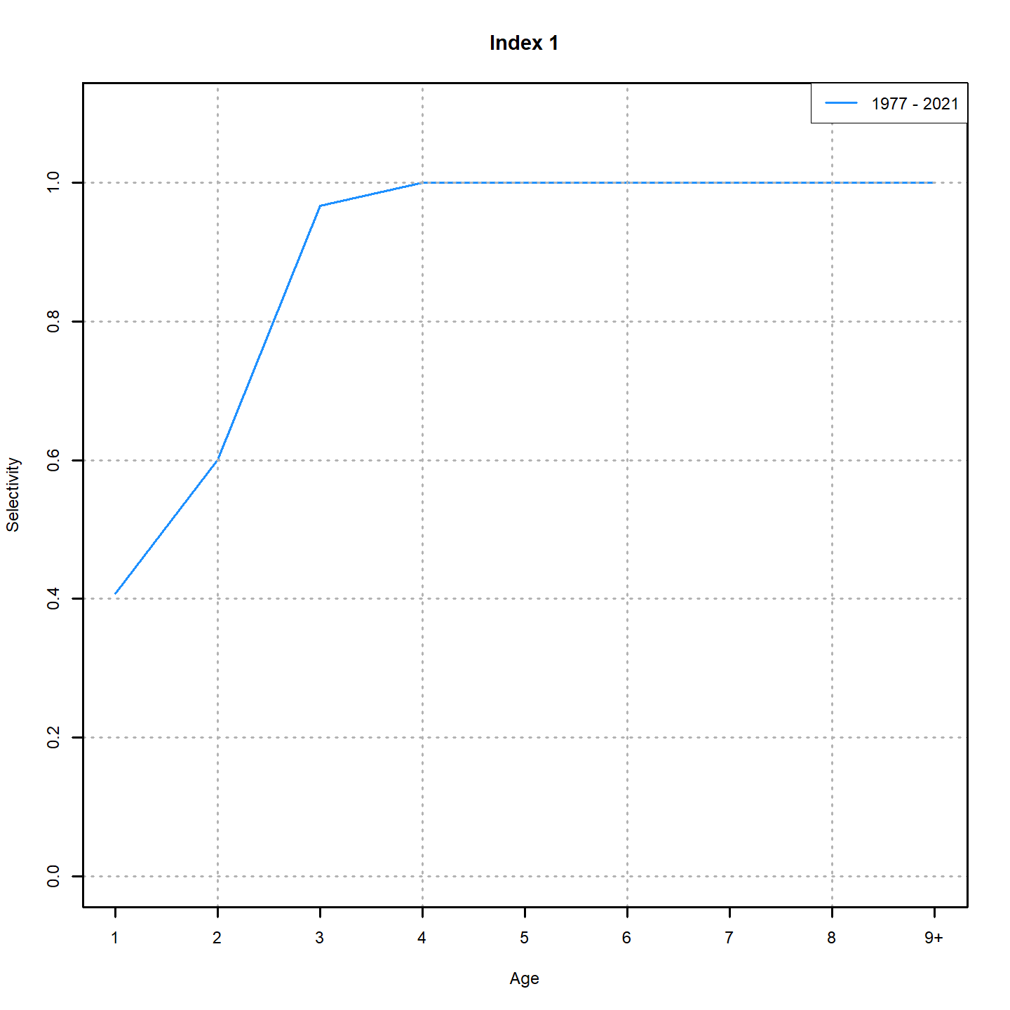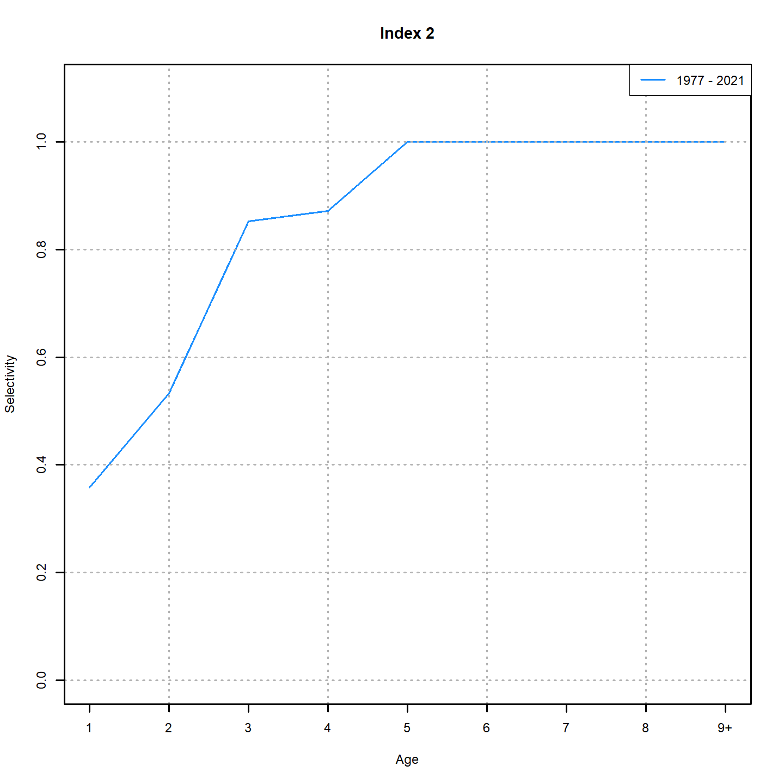

Figure 7. Selectivity estimates from the ASAP-like WHAM model. Fleet 1 is the combined fishery fleet, Index 1 is the NMFS spring survey, and Index 2 is the NMFS fall survey.

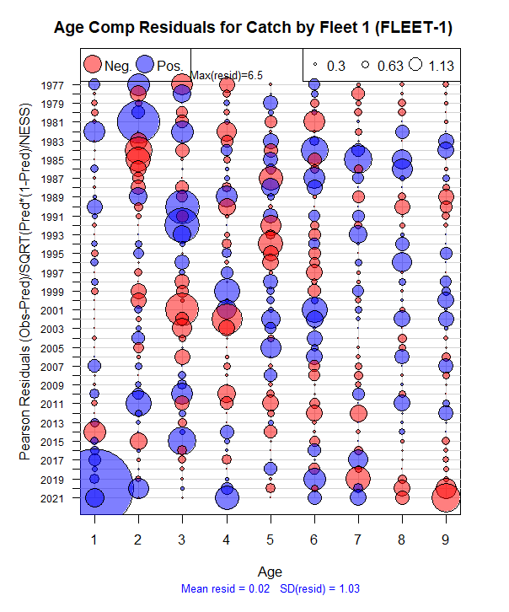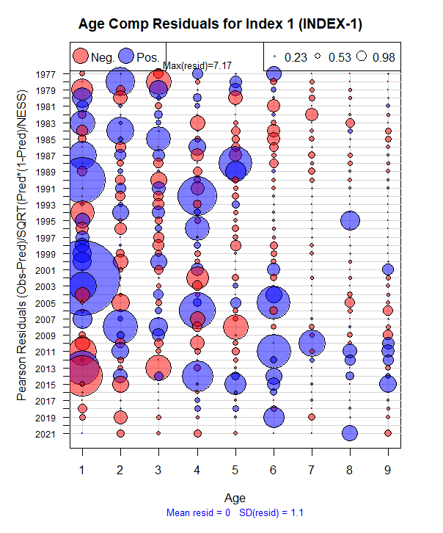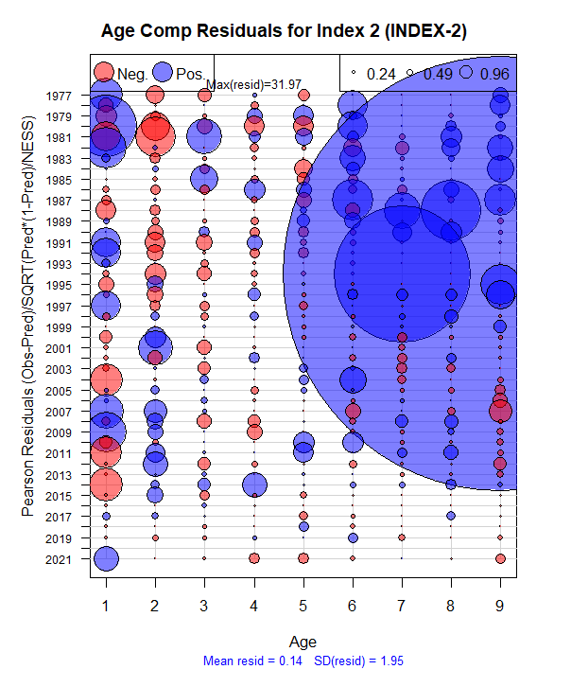

Figure 8. Age-composition raw residuals for the WHAM model. Fleet 1 is the combined fishery fleet, Index 1 is the NMFS spring survey, and Index 2 is the NMFS fall survey.

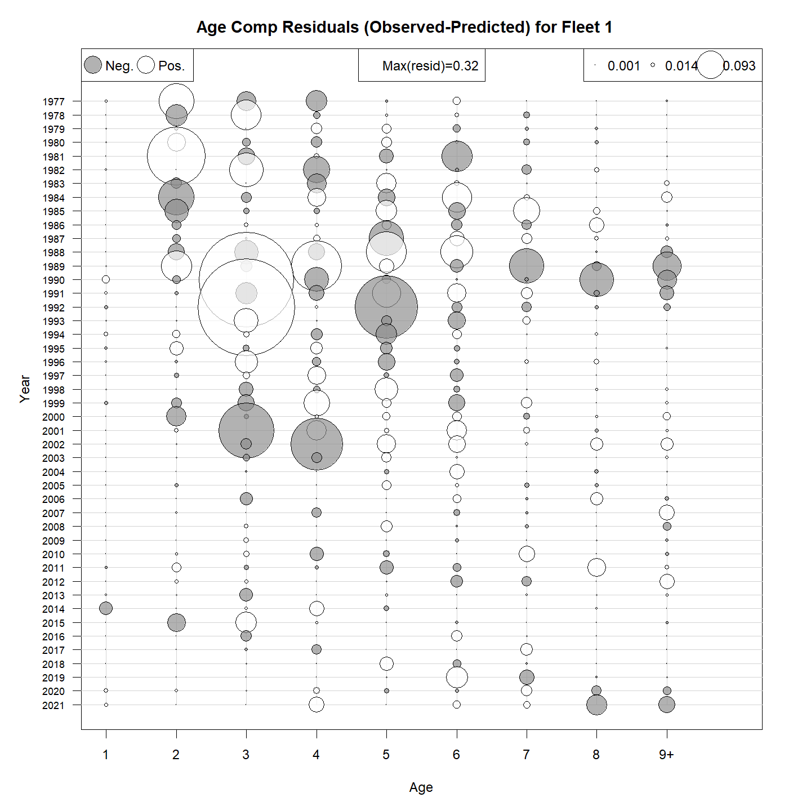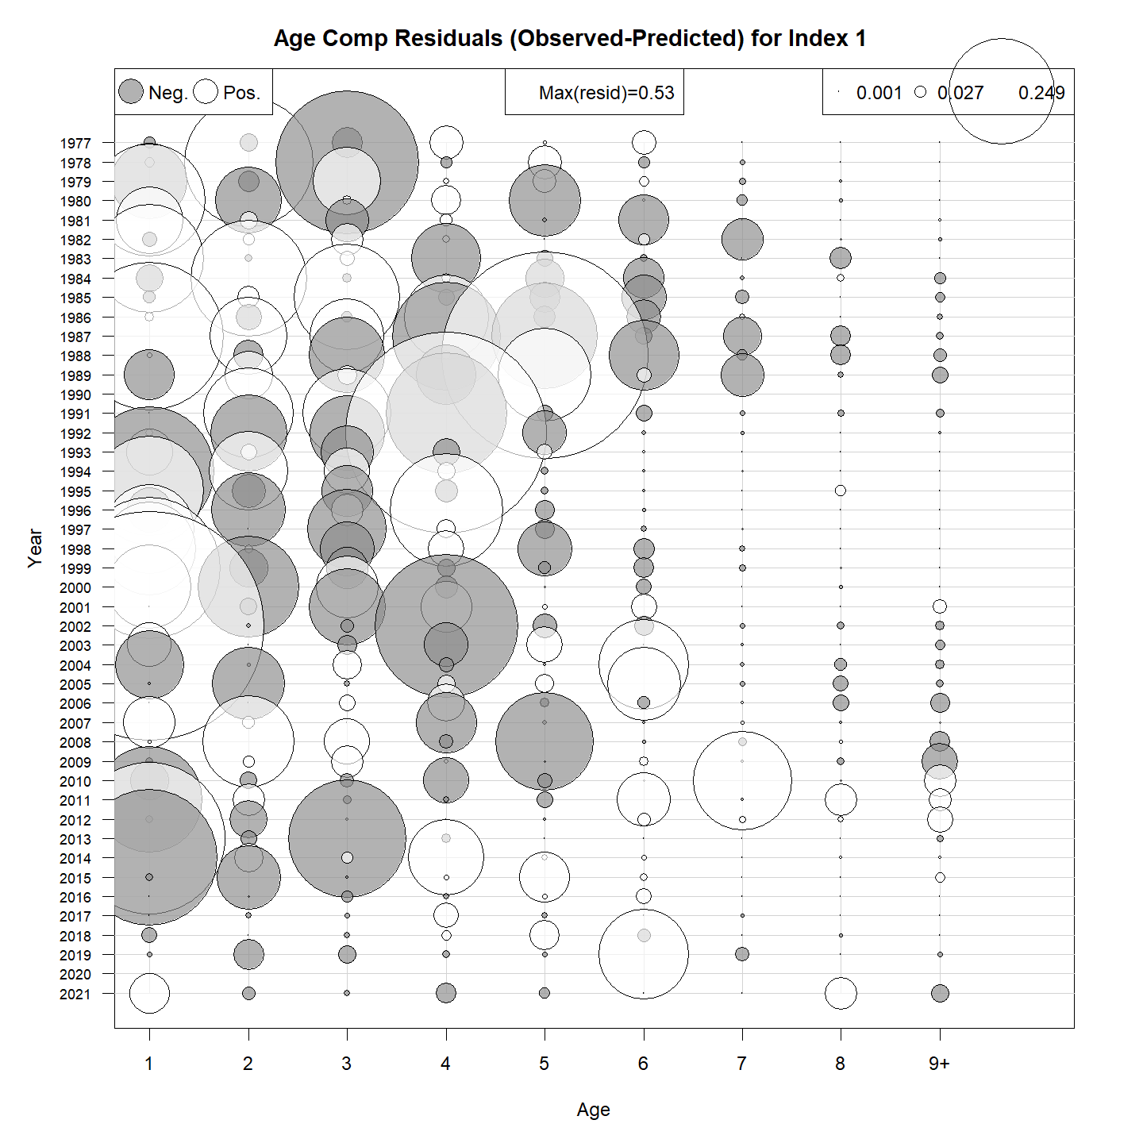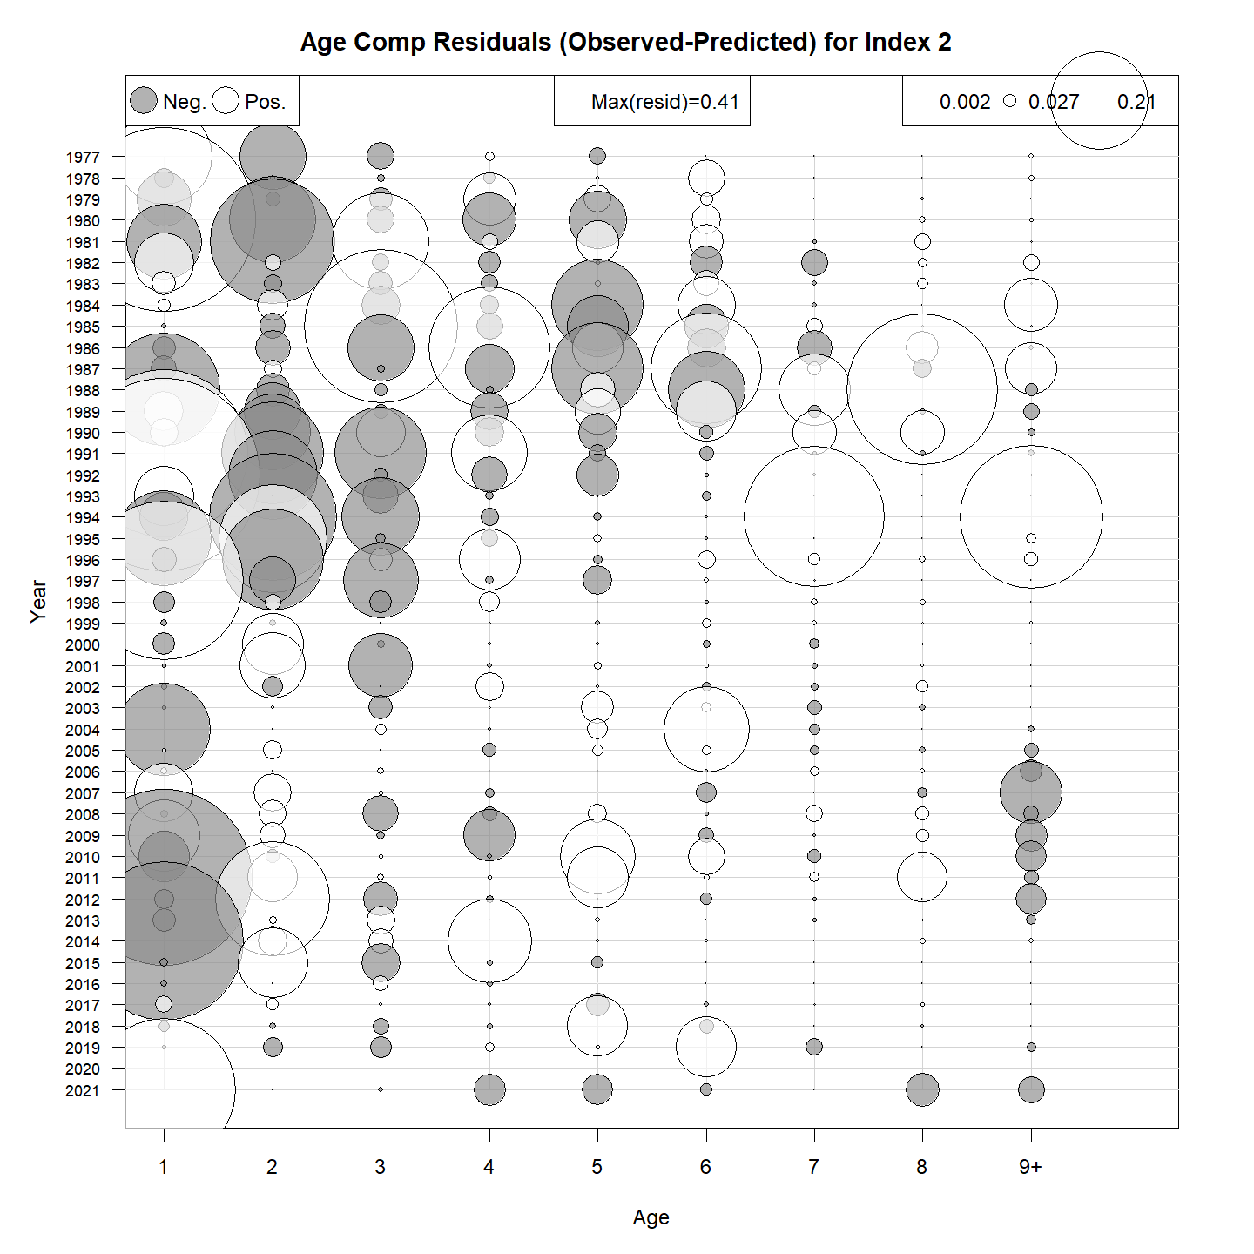

Figure 9. Age-composition Pearson residuals for the ASAP-like WHAM model. Fleet 1 is the combined fishery fleet, Index 1 is the NMFS spring survey, and Index 2 is the NMFS fall survey.

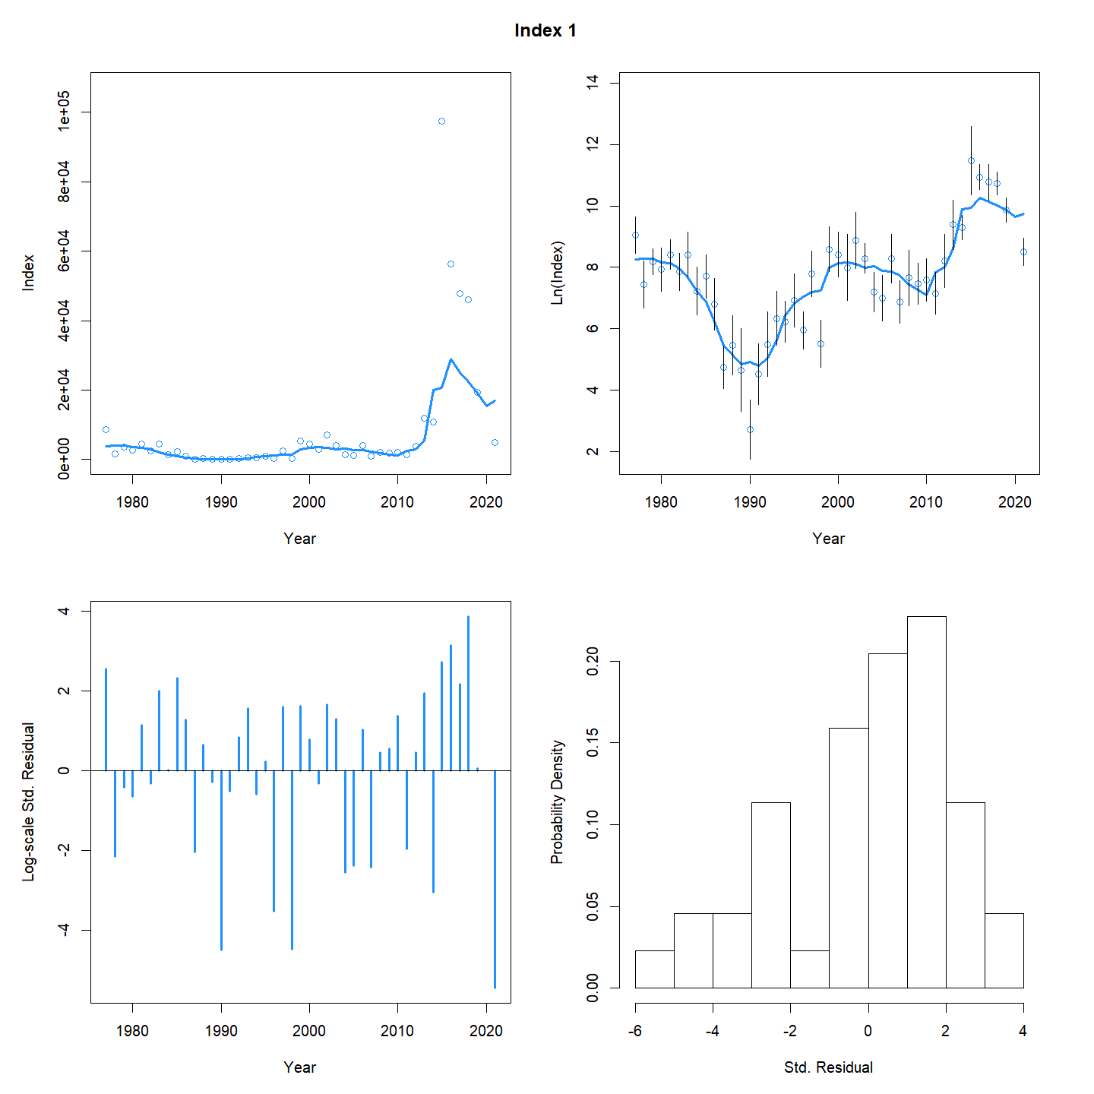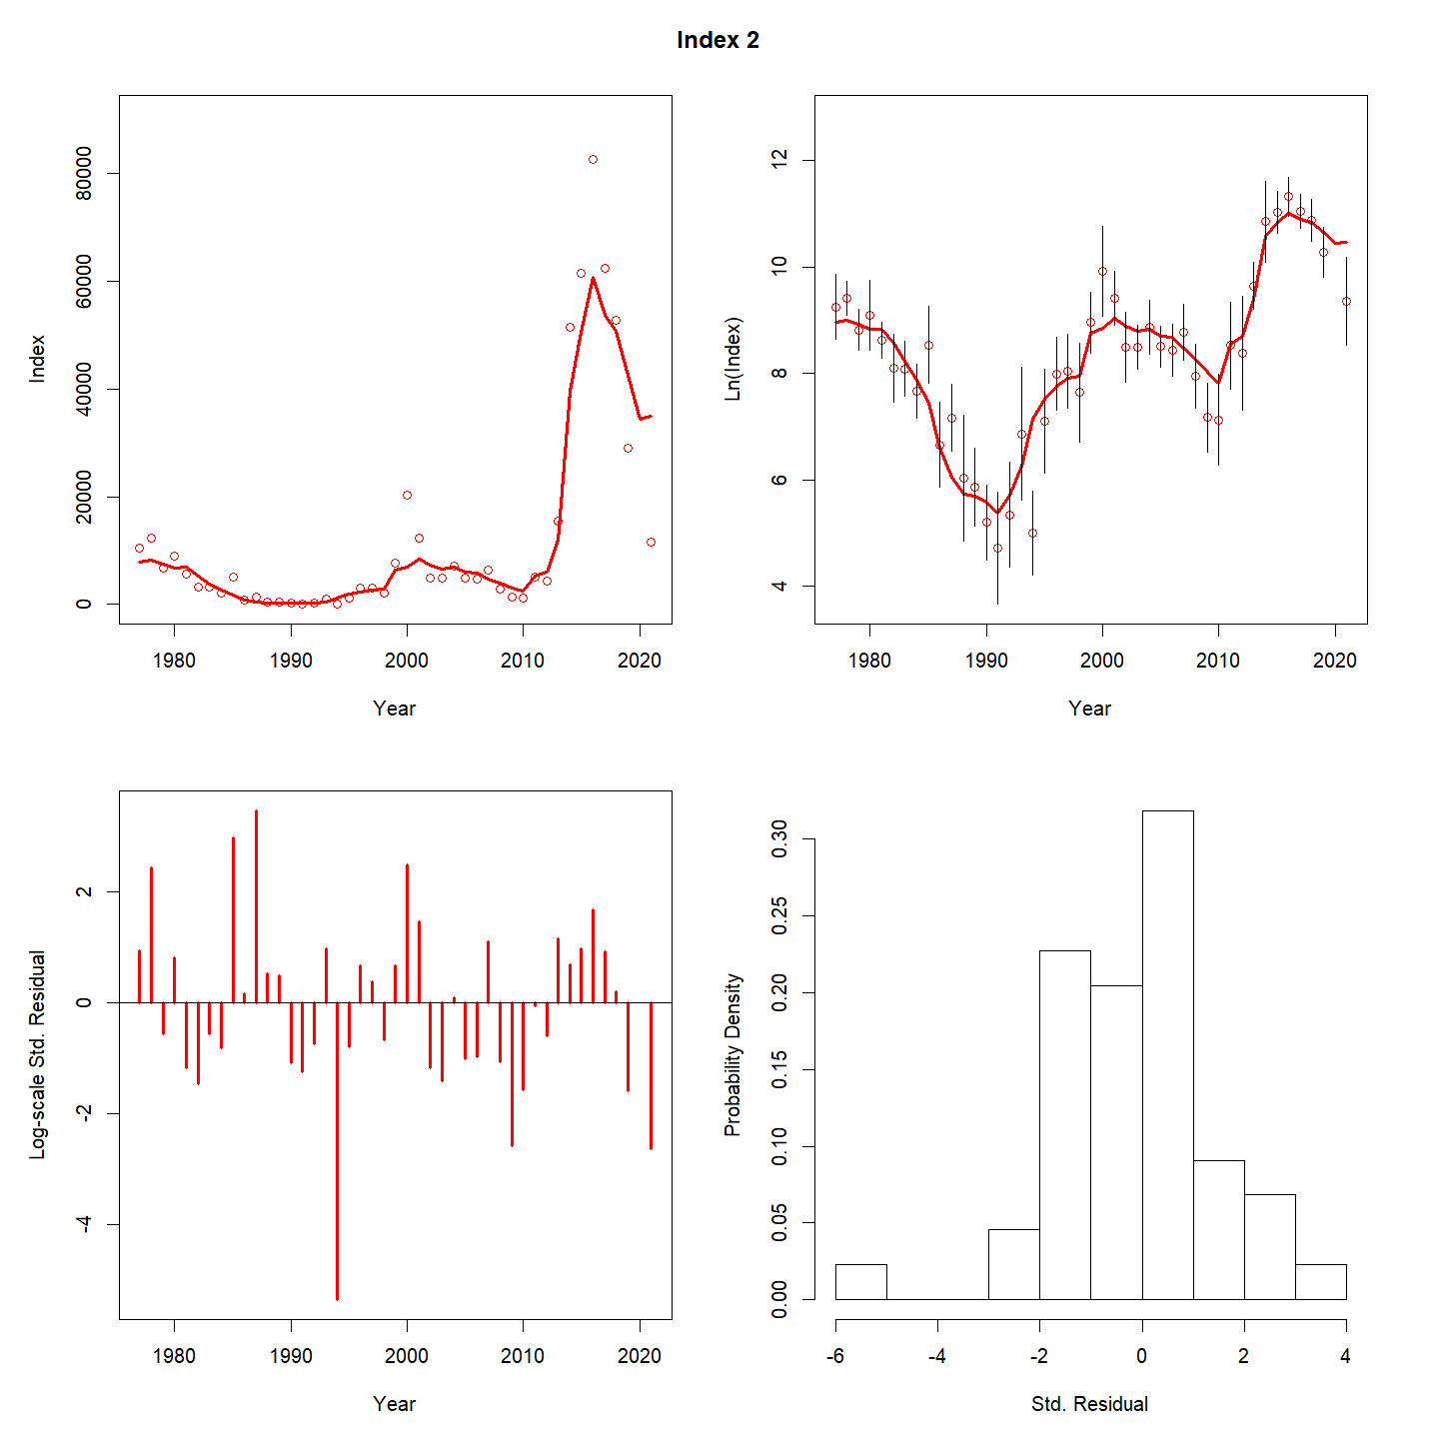

Figure 10. ASAP-like WHAM model fit to the NMFS BTS aggregate indices. Note the large residual in the terminal year in both surveys. Index 1 is the NMFS spring survey, and Index 2 is the NMFS fall survey.

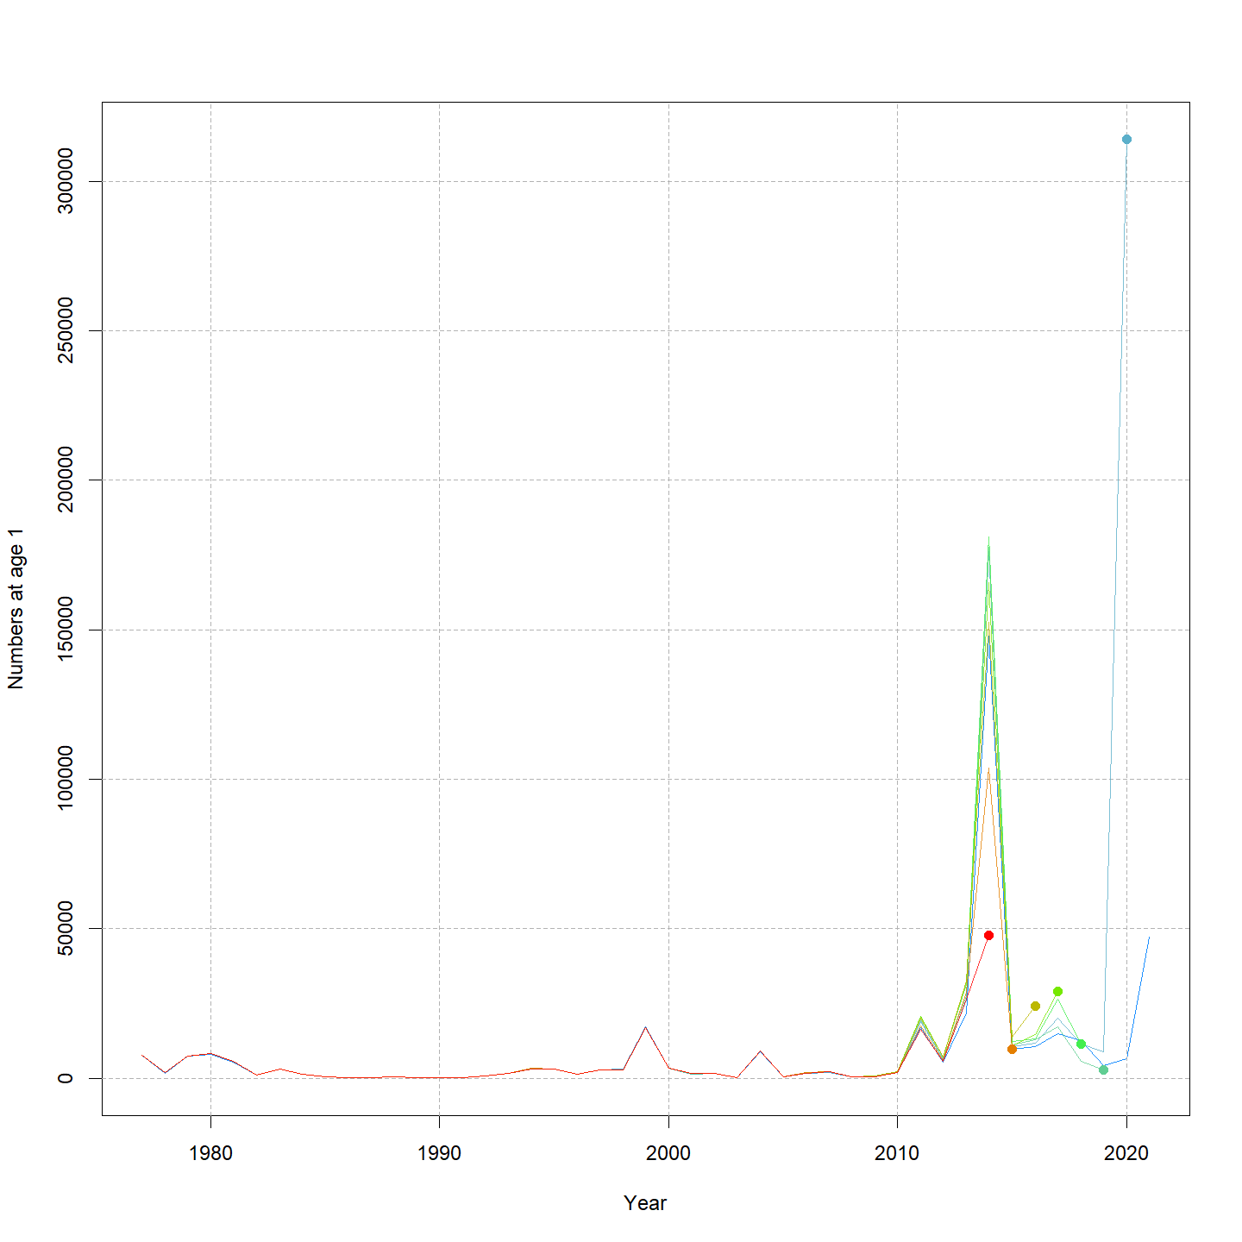

Figure 11. Retrospective estimates of recruitment from the WHAM ASAP-like model. Note the large retrospective change in the 2020 recruitment estimate.

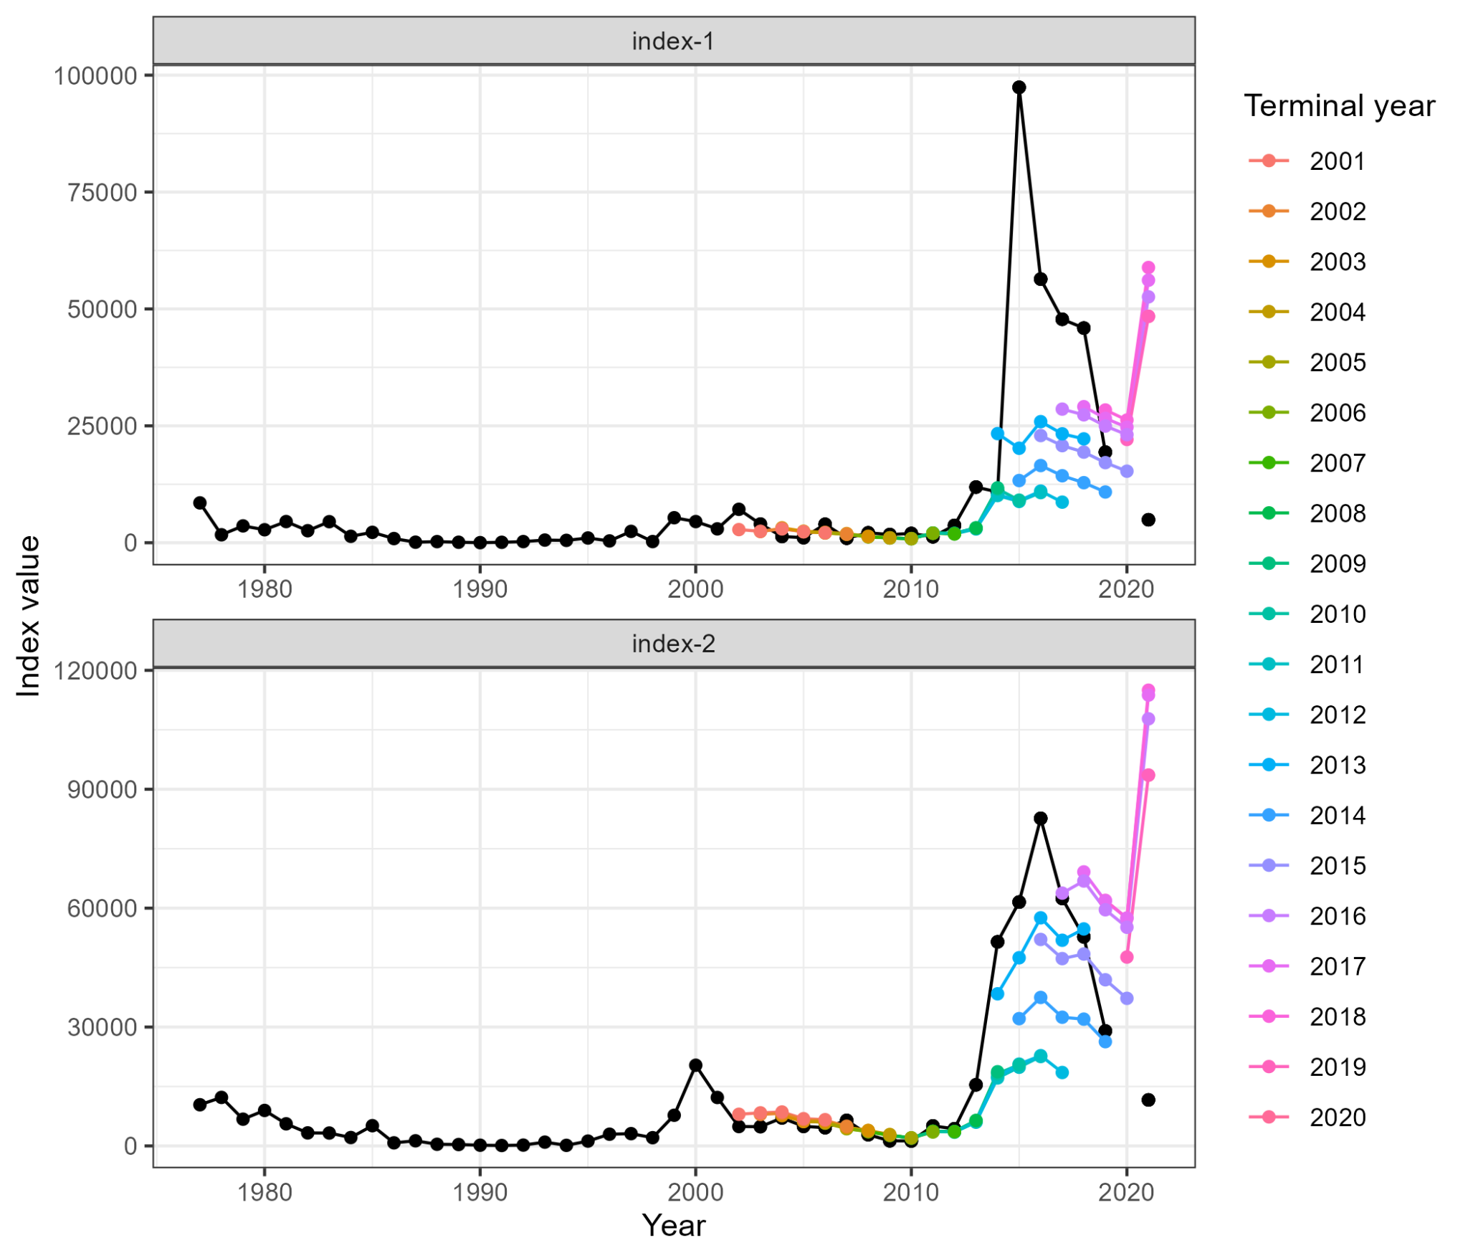

Figure 12. Predicted versus observed aggregate survey indices for the WHAM ASAP-like model. Colored points are the predictions from the indicated terminal year.

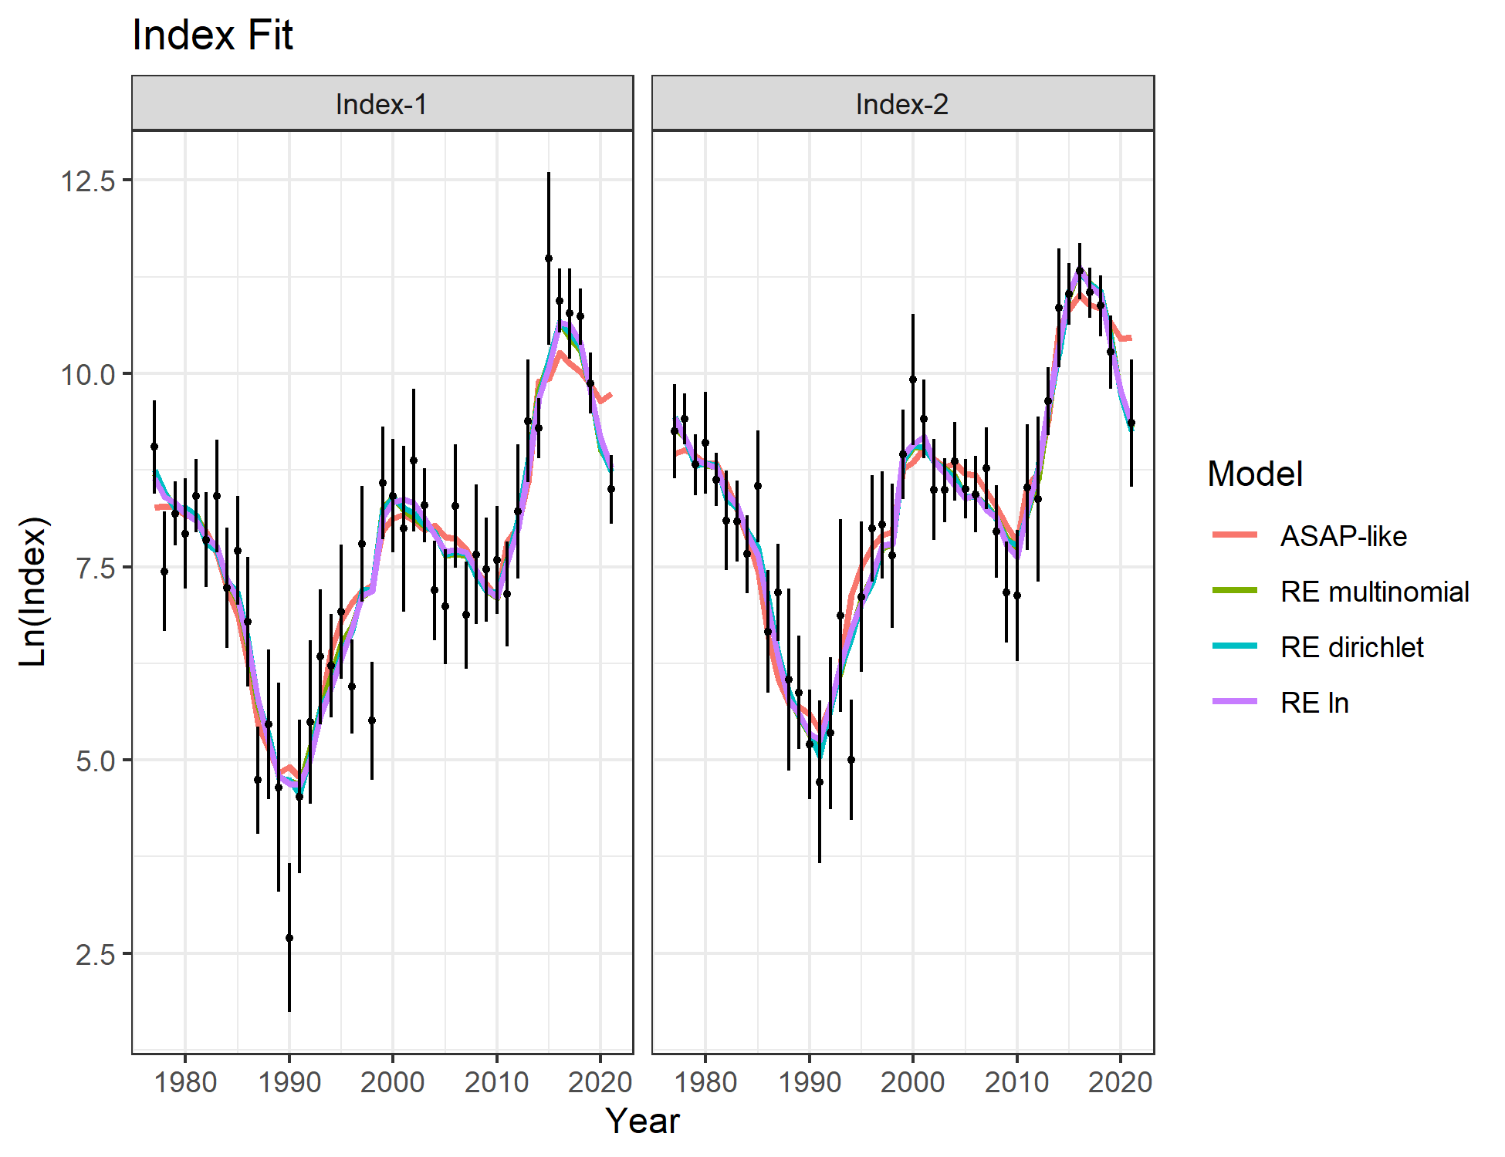

Figure 13. Fits to the NMFS BTS aggregate indices for all WHAM models. Note the improved fit of the RE models in the terminal year compared to the ASAP-like model.

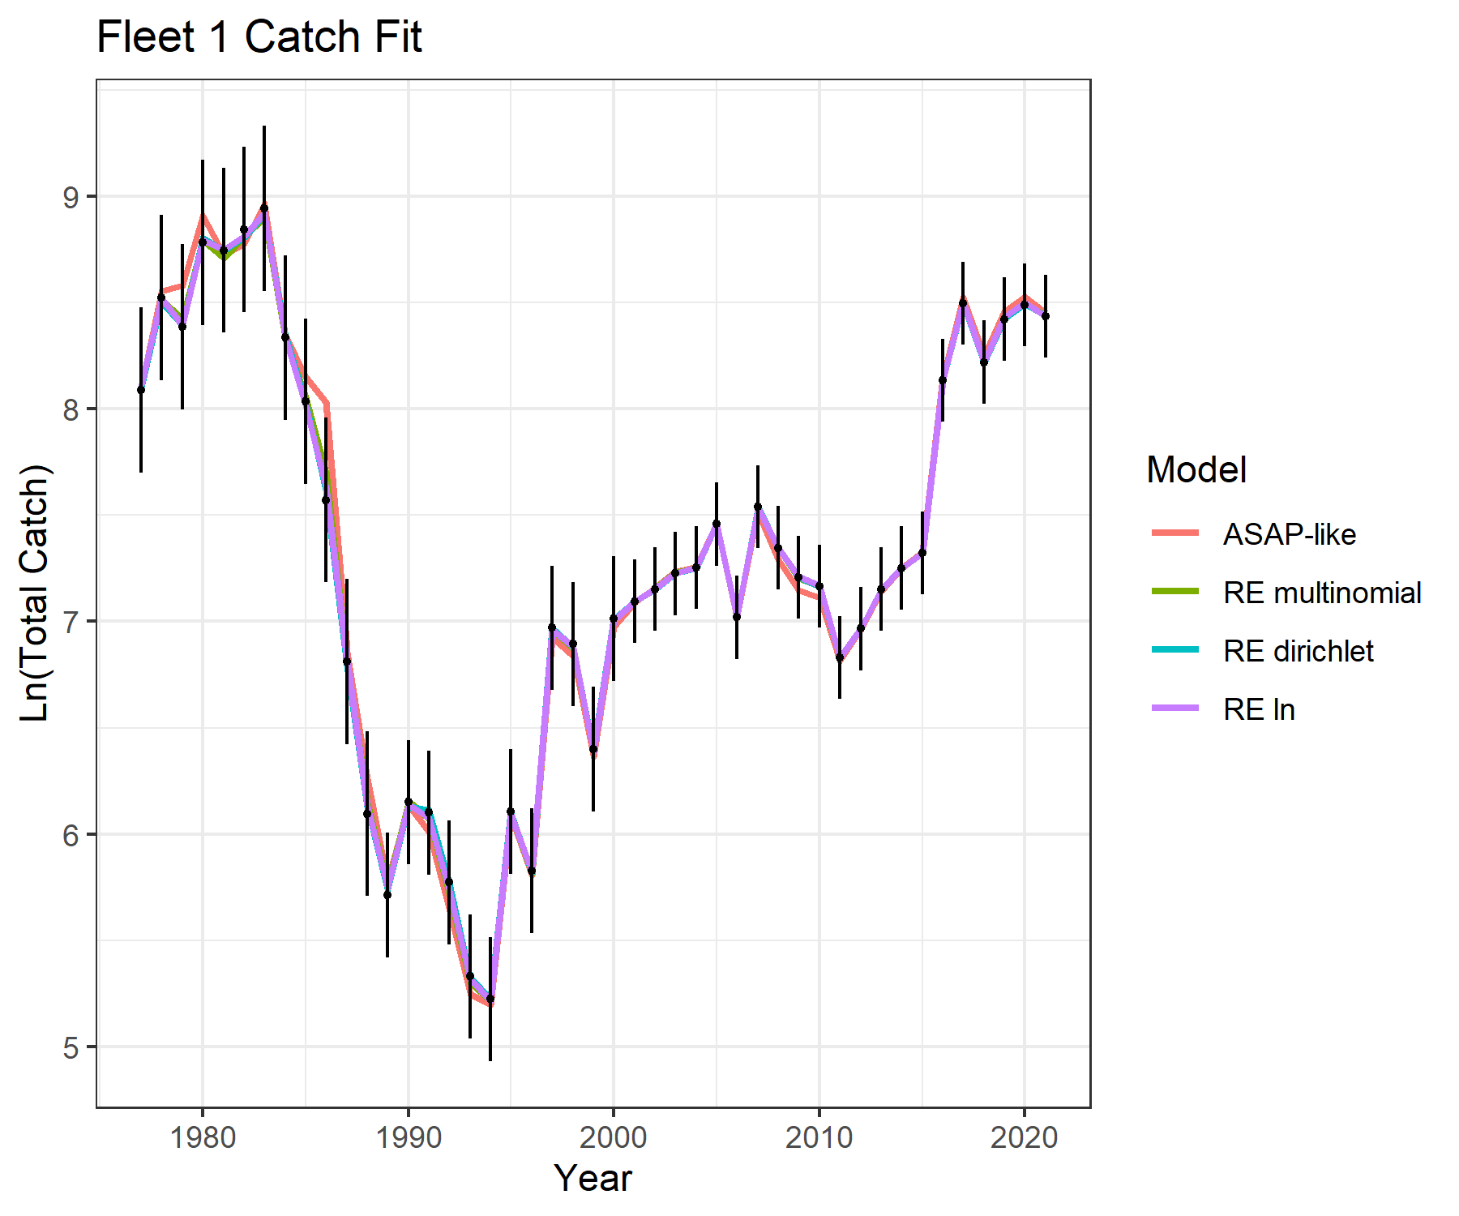

Figure 14. Fits to the fleet aggregate catch for all WHAM models.

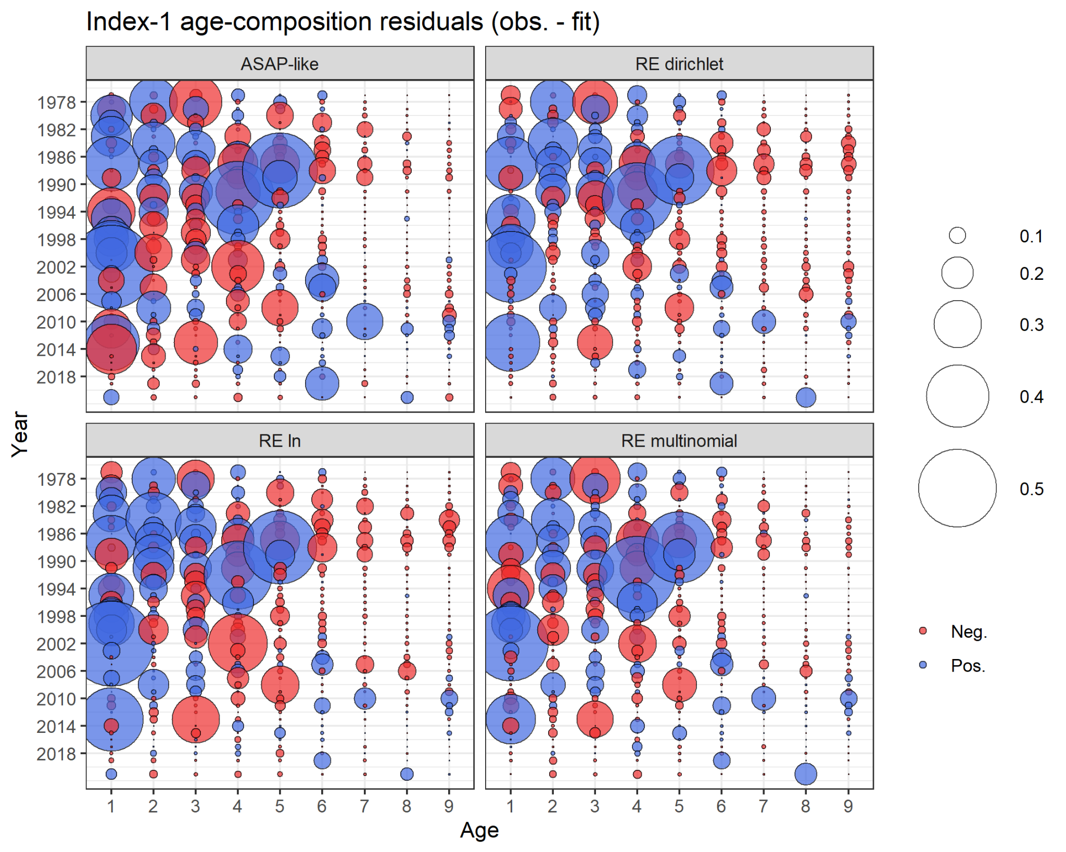

Figure 15. Age-composition residuals for the NMFS spring BTS for each WHAM model run.

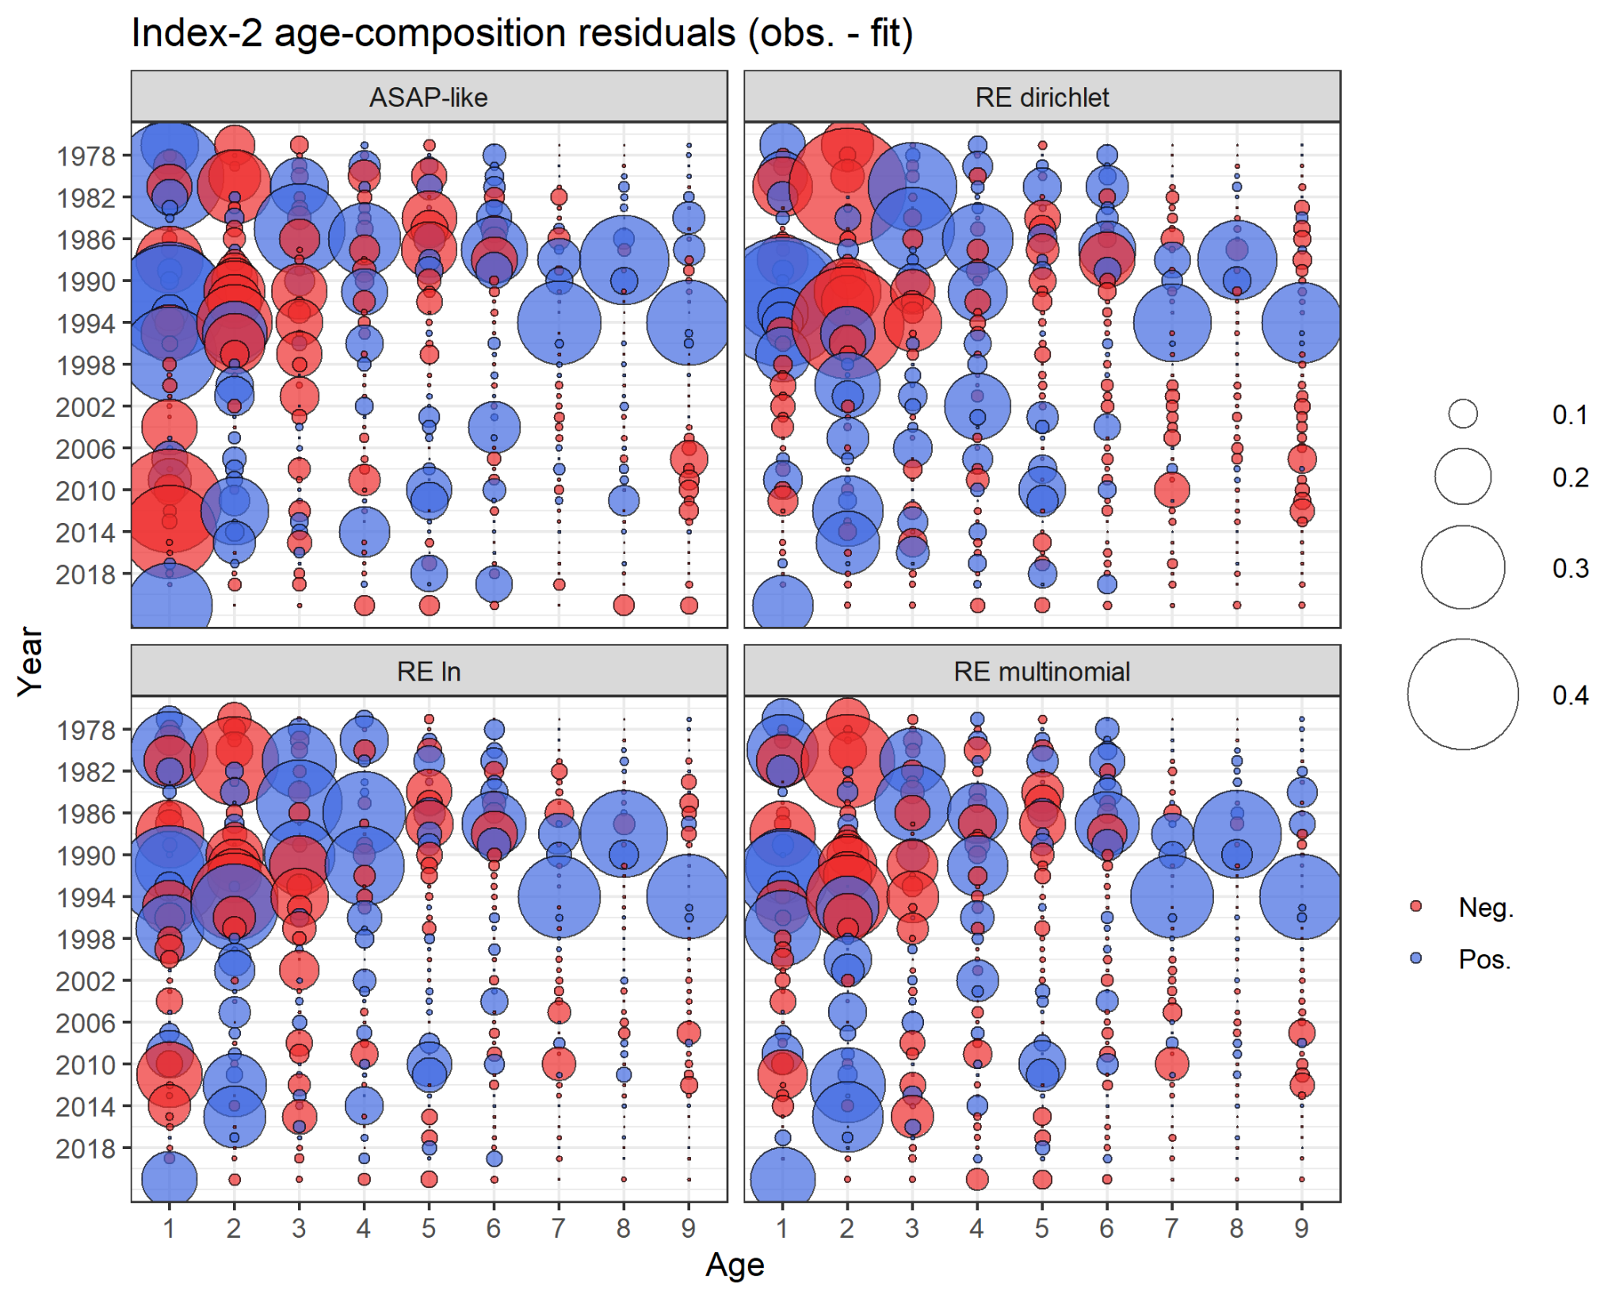

Figure 16. Age-composition residuals for the NMFS fall BTS for each WHAM model run.

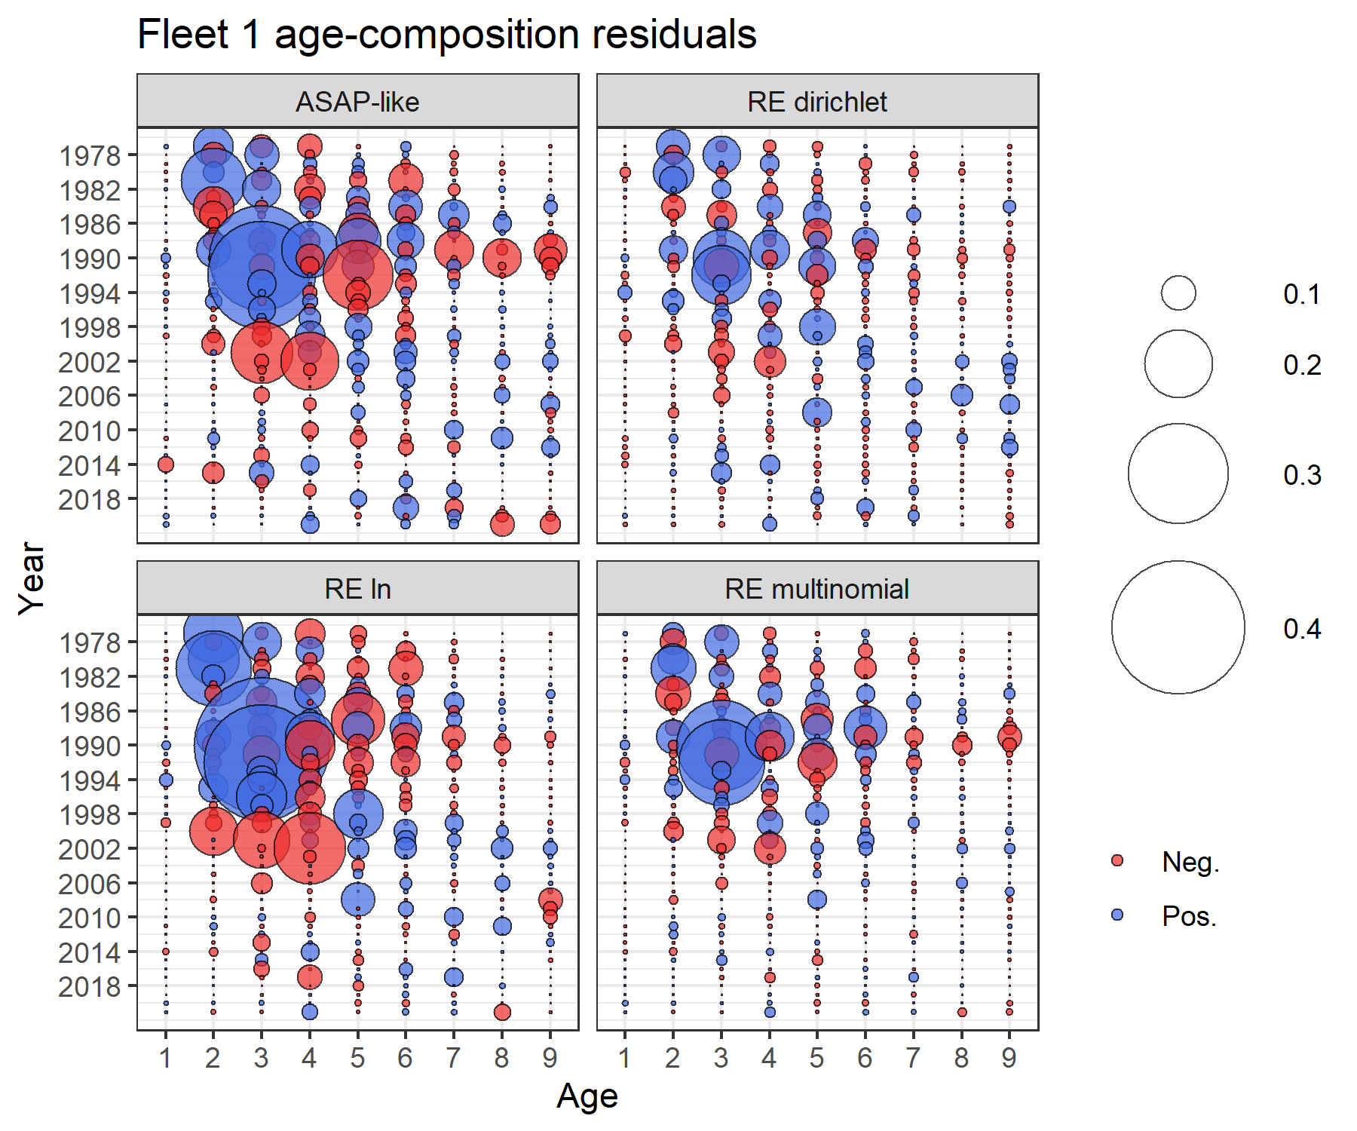

Figure 17. Age-composition residuals for the fleet catch for each WHAM model run.

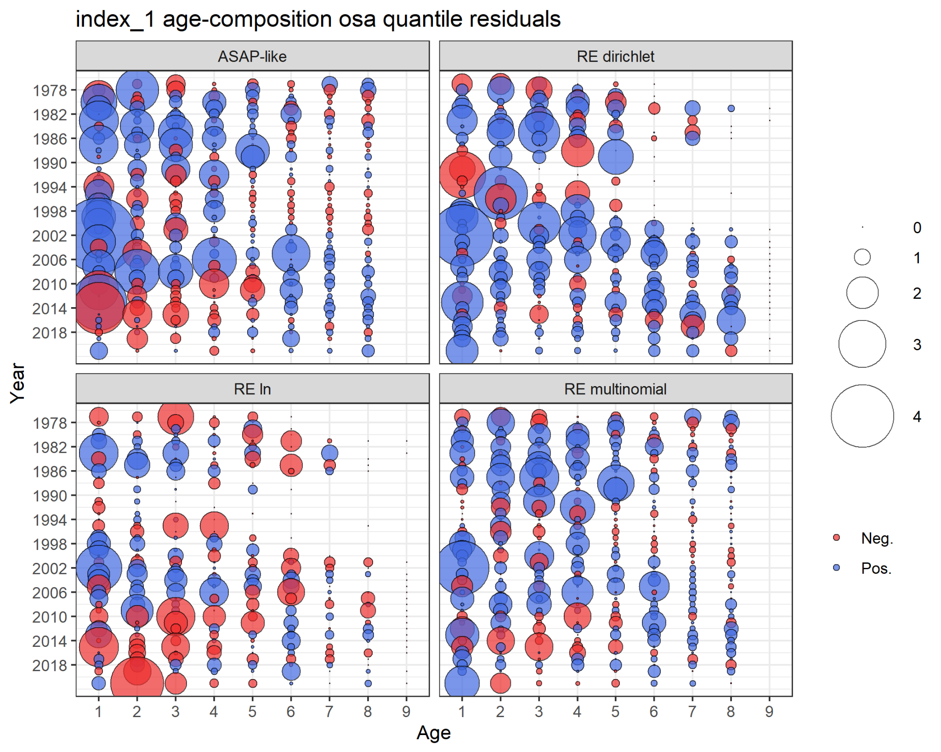

Figure 18. Age-composition OSA residuals for the NMFS spring BTS for each WHAM model run.

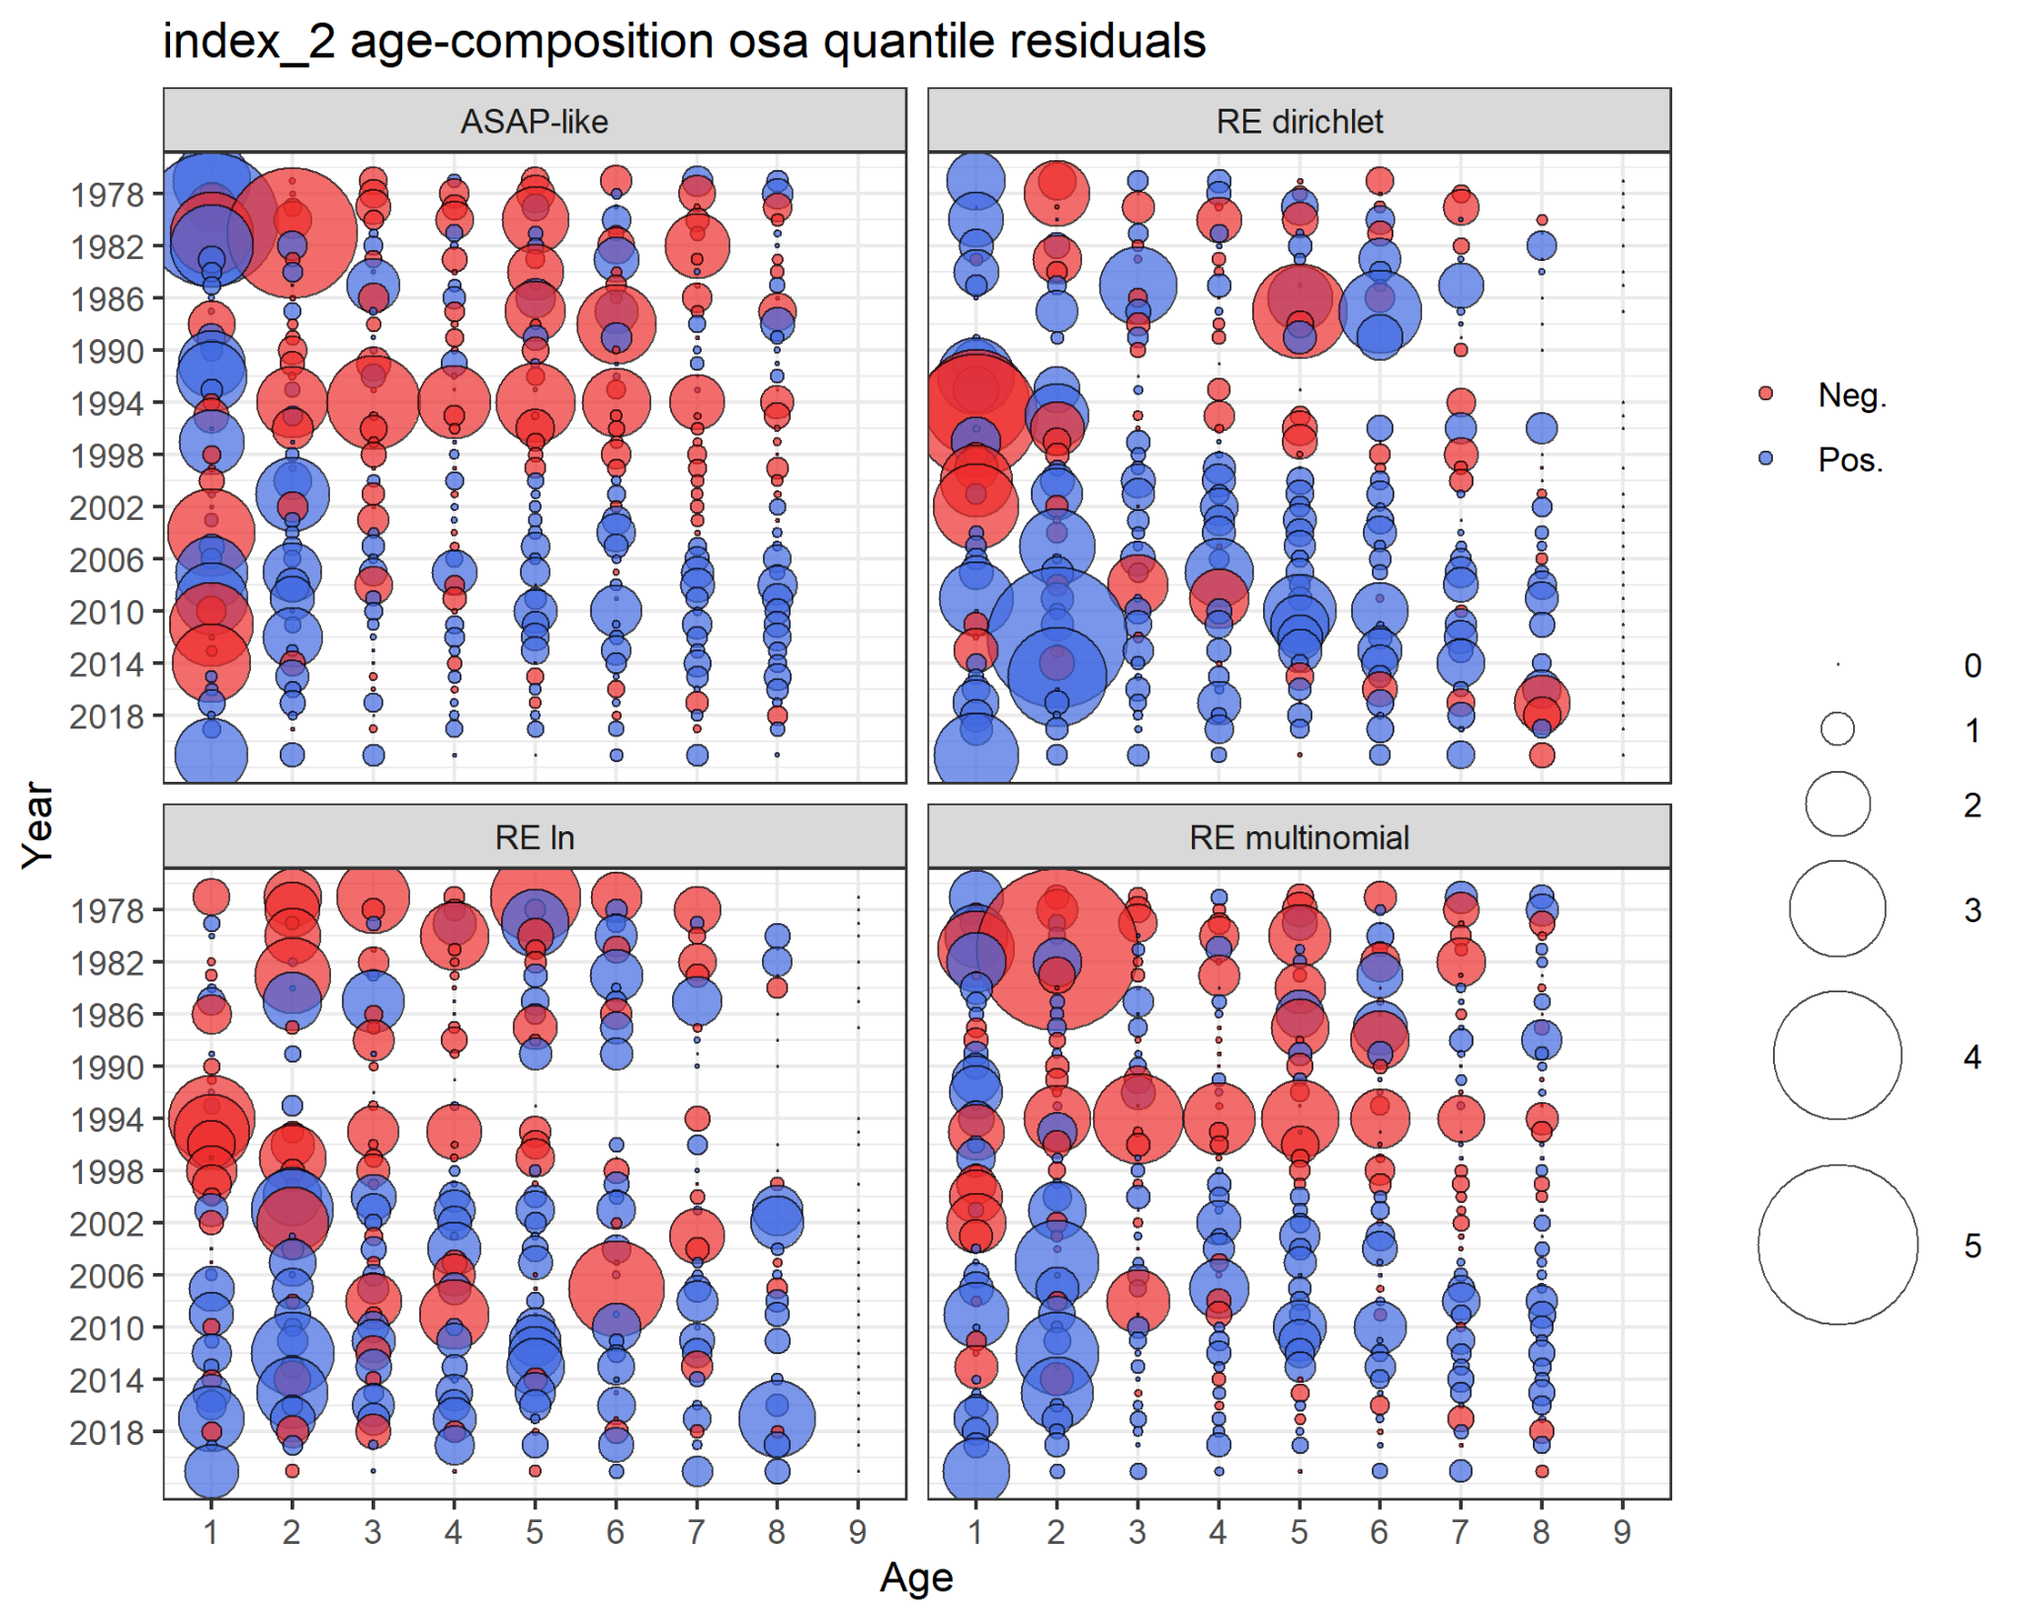

Figure 19. Age-composition OSA residuals for the NMFS fall BTS for each WHAM model run.

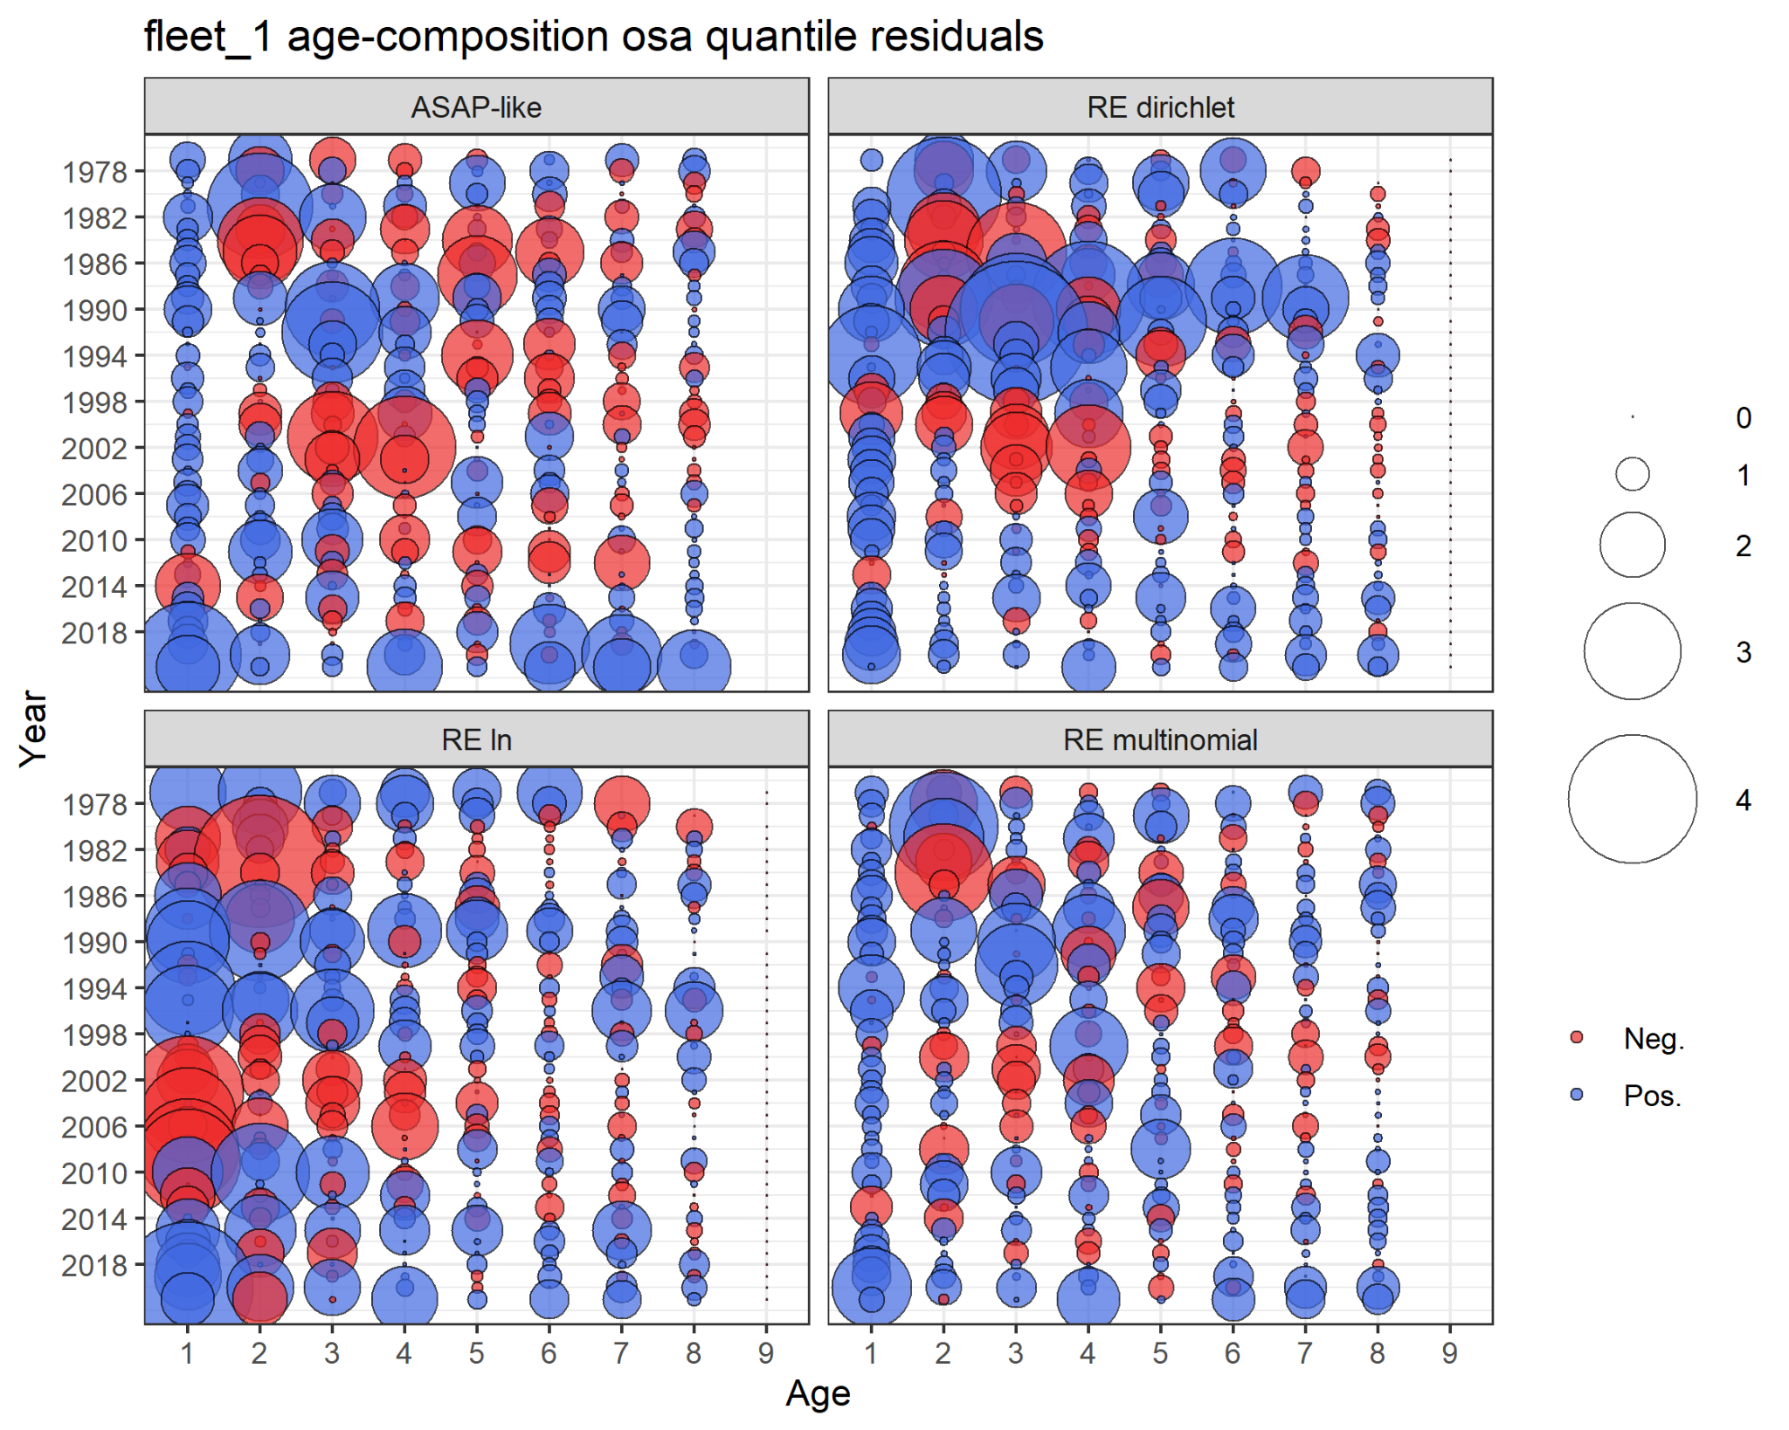

Figure 20. Age-composition OSA residuals for the fleet catch for each WHAM model run.

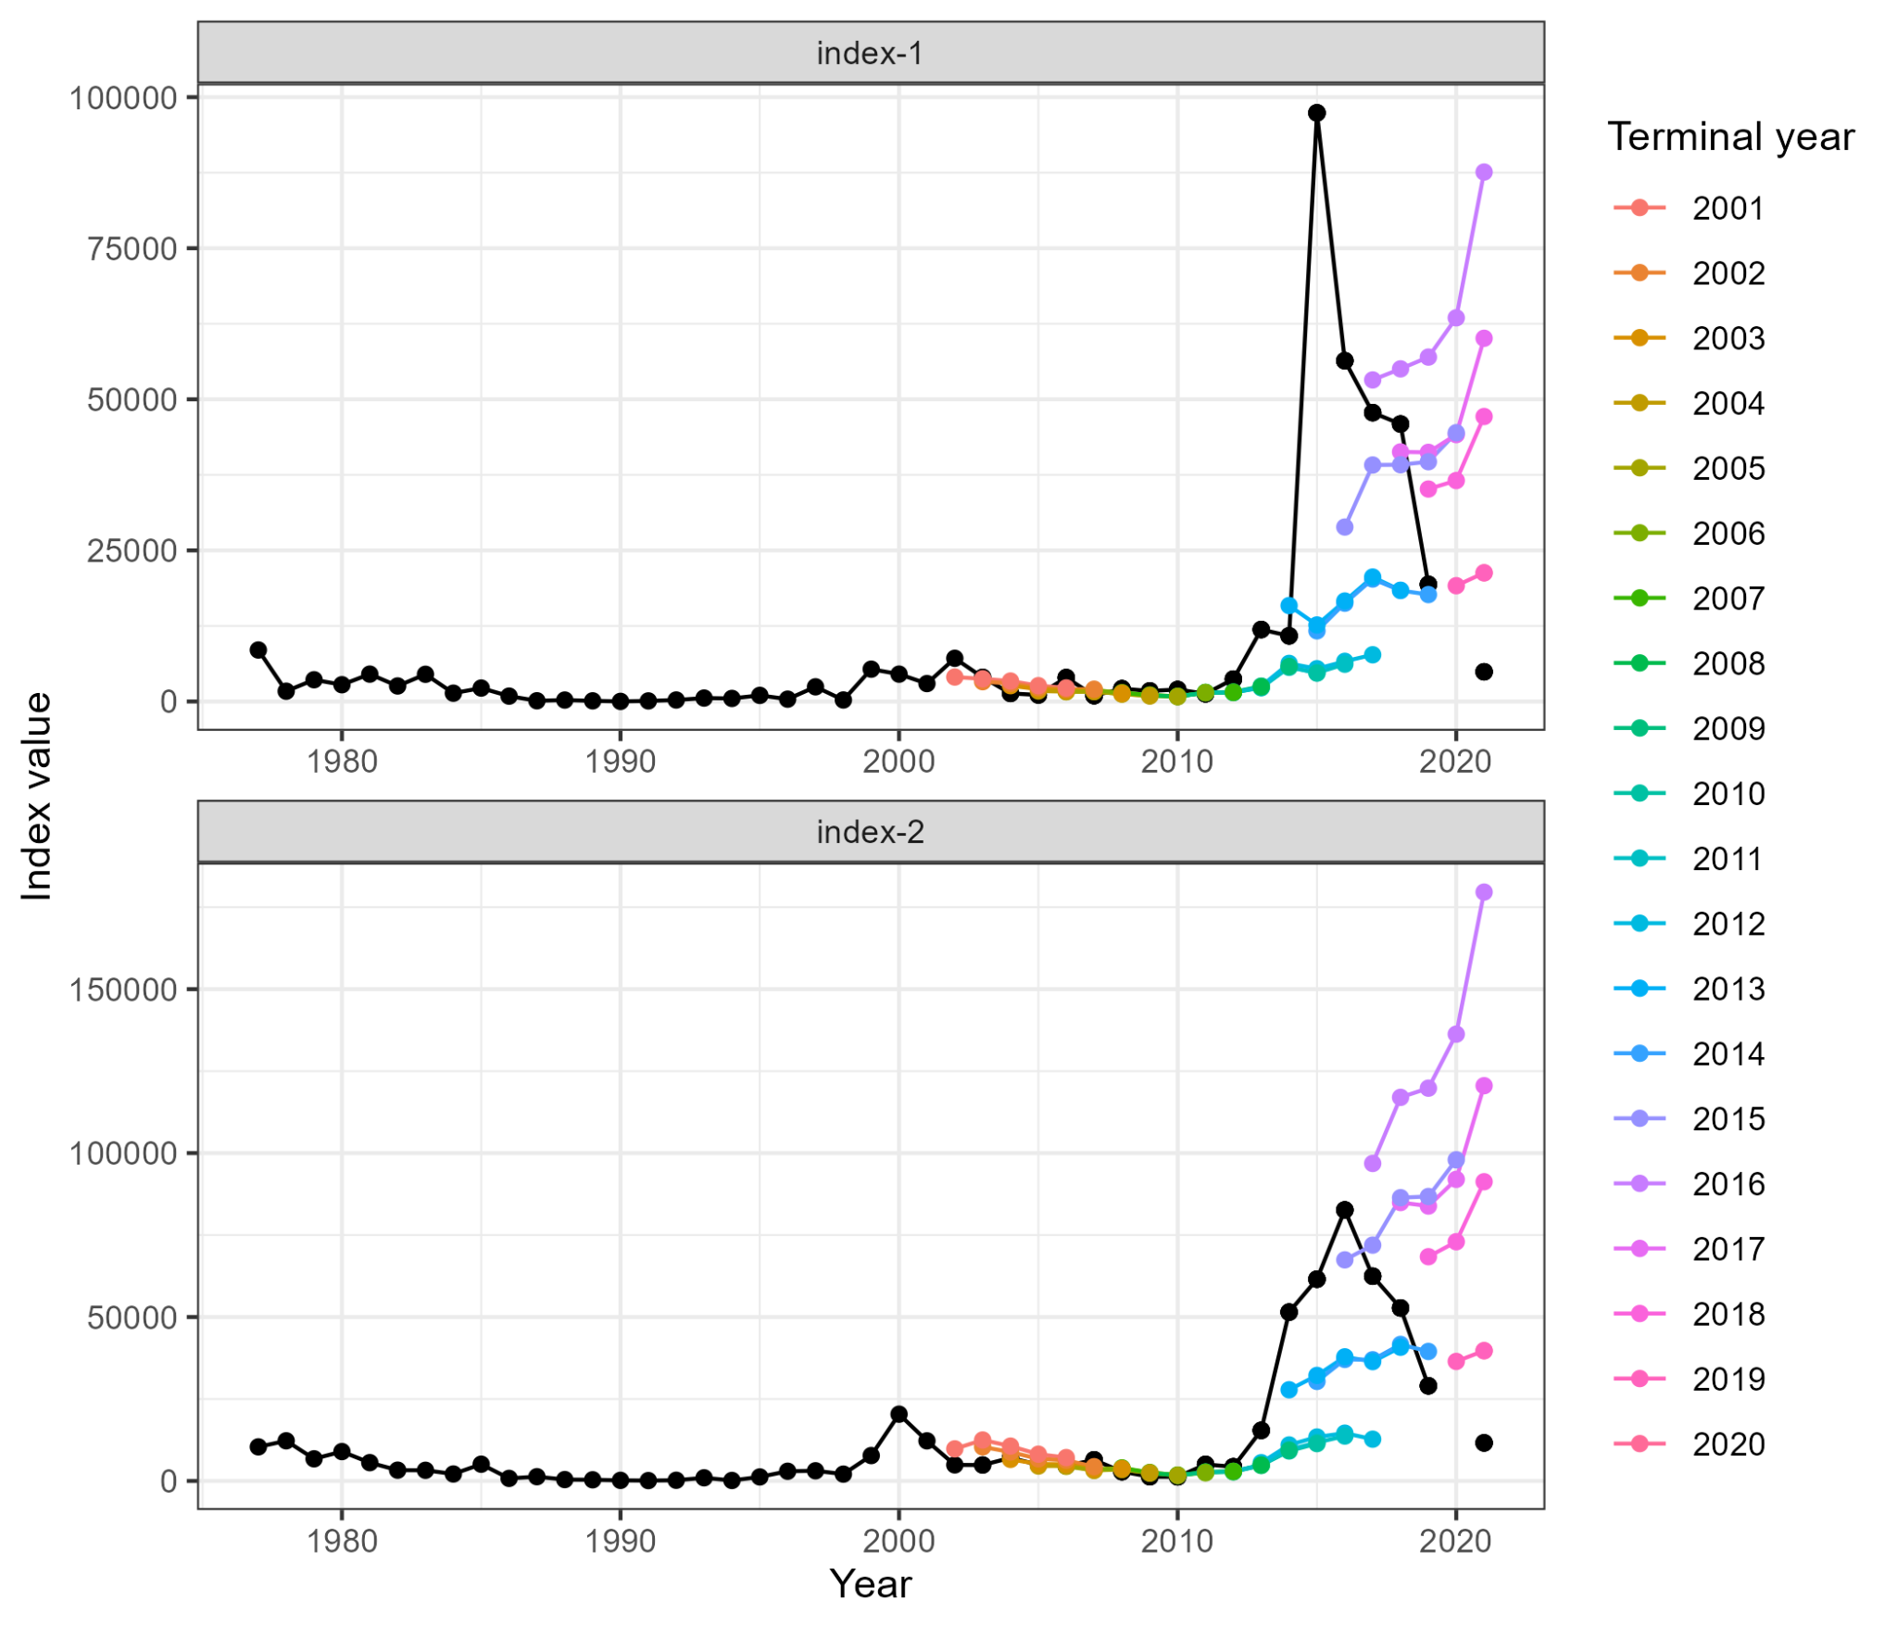

Figure 21. Predicted versus observed aggregate survey indices for the WHAM RE logistic-normal model. Colored points are the predictions from the indicated terminal year.

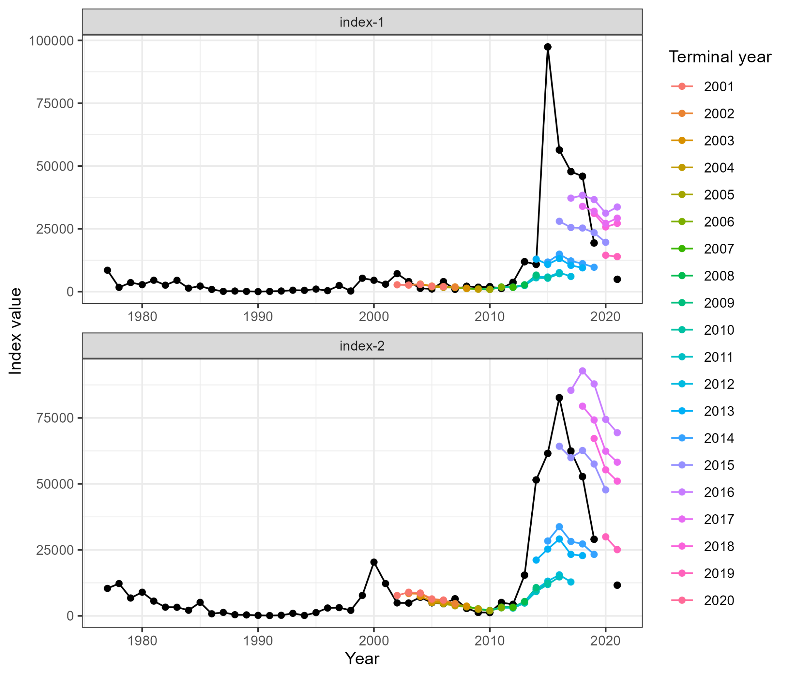

Figure 22. Predicted versus observed aggregate survey indices for the WHAM RE multinomial model. Colored points are the predictions from the indicated terminal year.

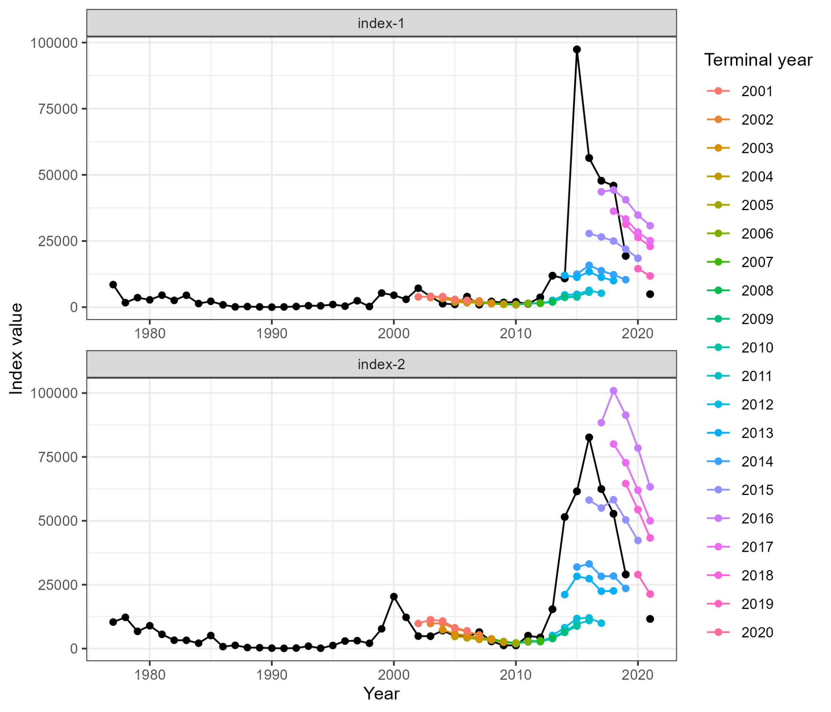

Figure 23. Predicted versus observed aggregate survey indices for the WHAM RE Dirichlet model. Colored points are the predictions from the indicated terminal year.

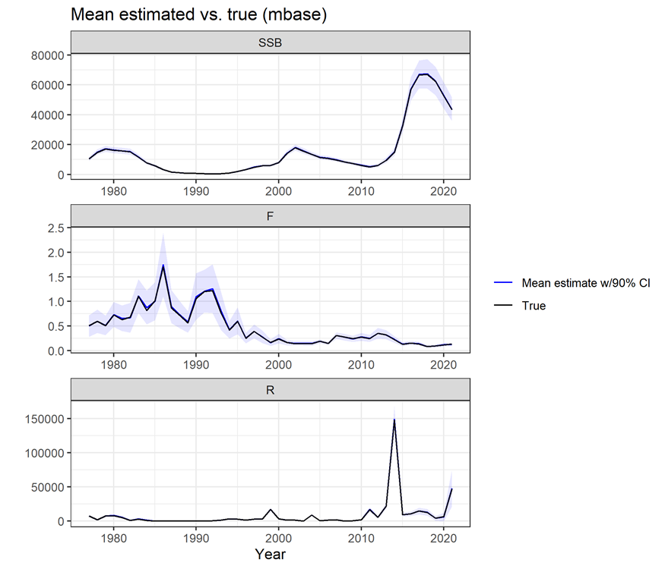

Figure 24. Self-simulation fit and true values of SSB, *F* and recruitment (*R*) for the WHAM ASAP-like model.

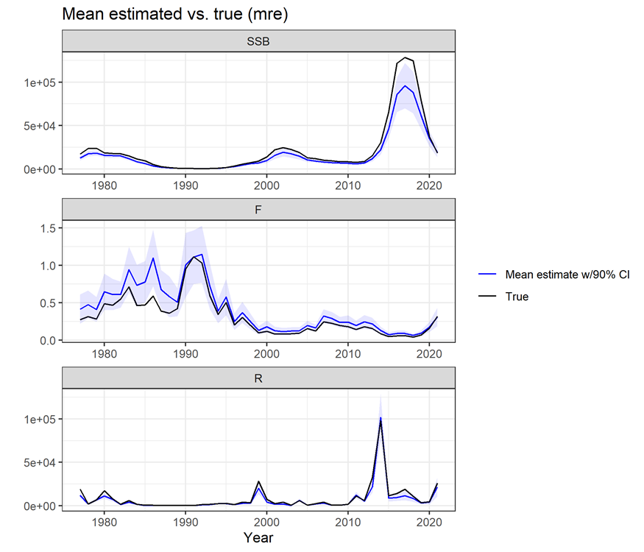

Figure 25. Self-simulation mean fit and true values of SSB, *F* and recruitment (*R)* for the RE multinomial model.

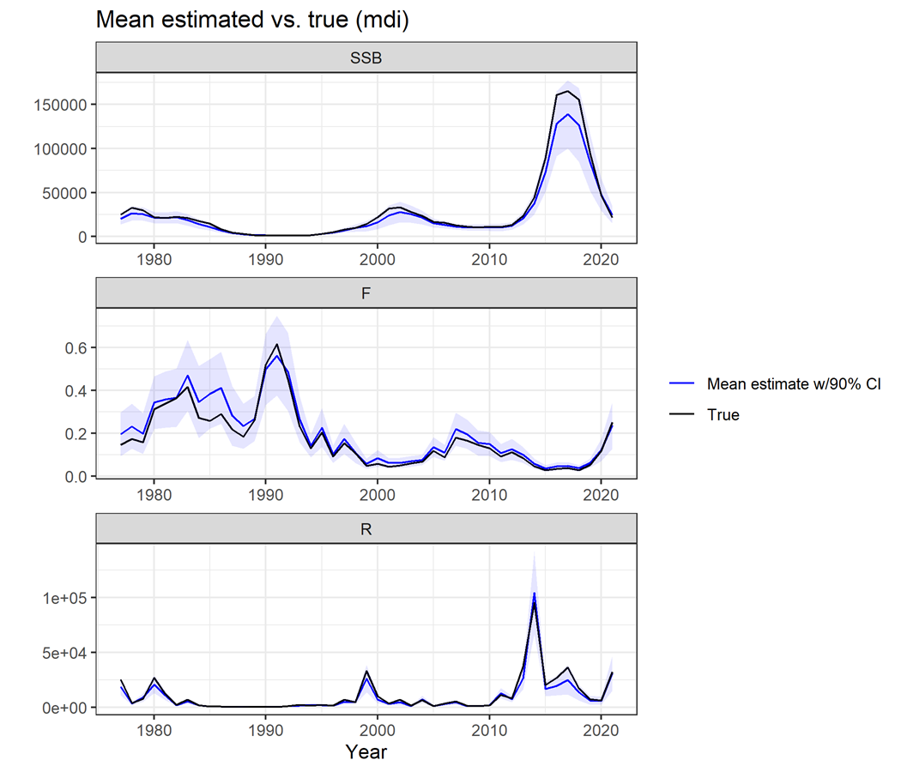

Figure 26. Self-simulation mean fit and true values of SSB, *F* and recruitment (*R)* for the RE Dirichlet model.

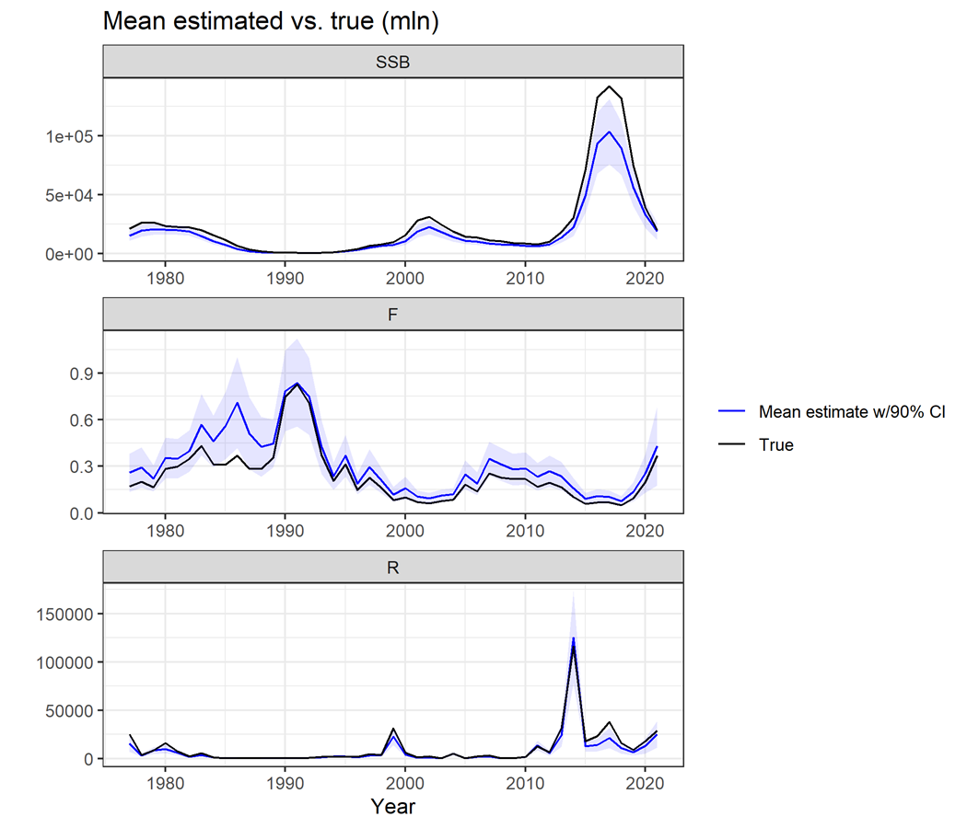

Figure 27. Self-simulation mean fit and true values of SSB, *F* and recruitment (*R)* for the RE logistic-normal model.

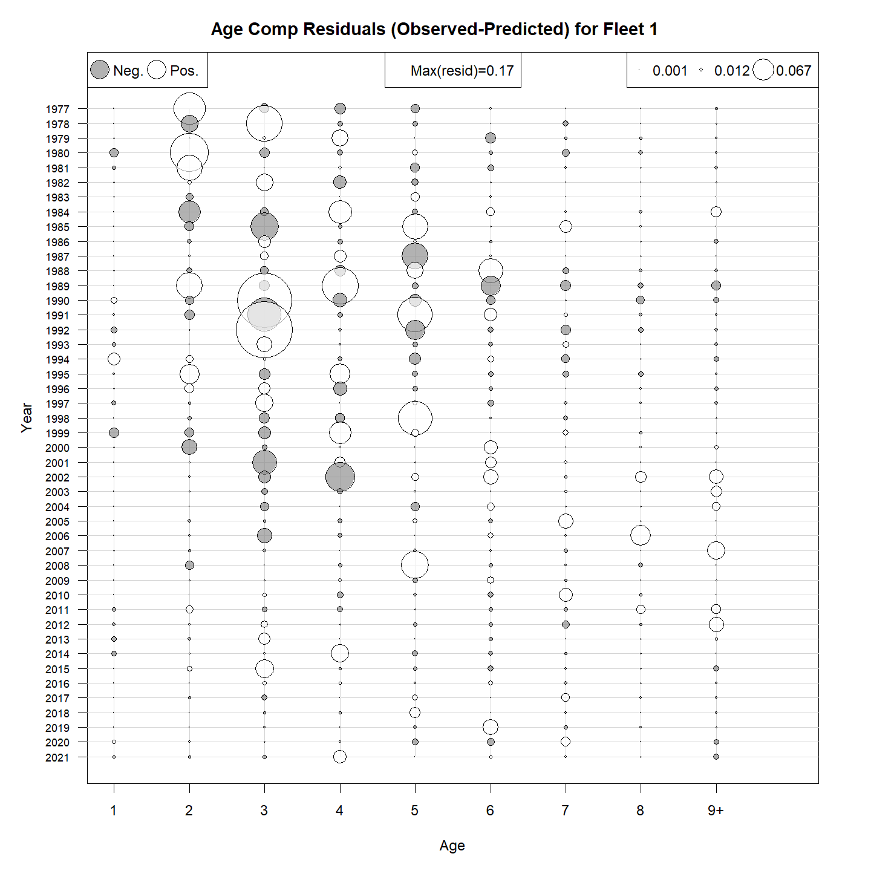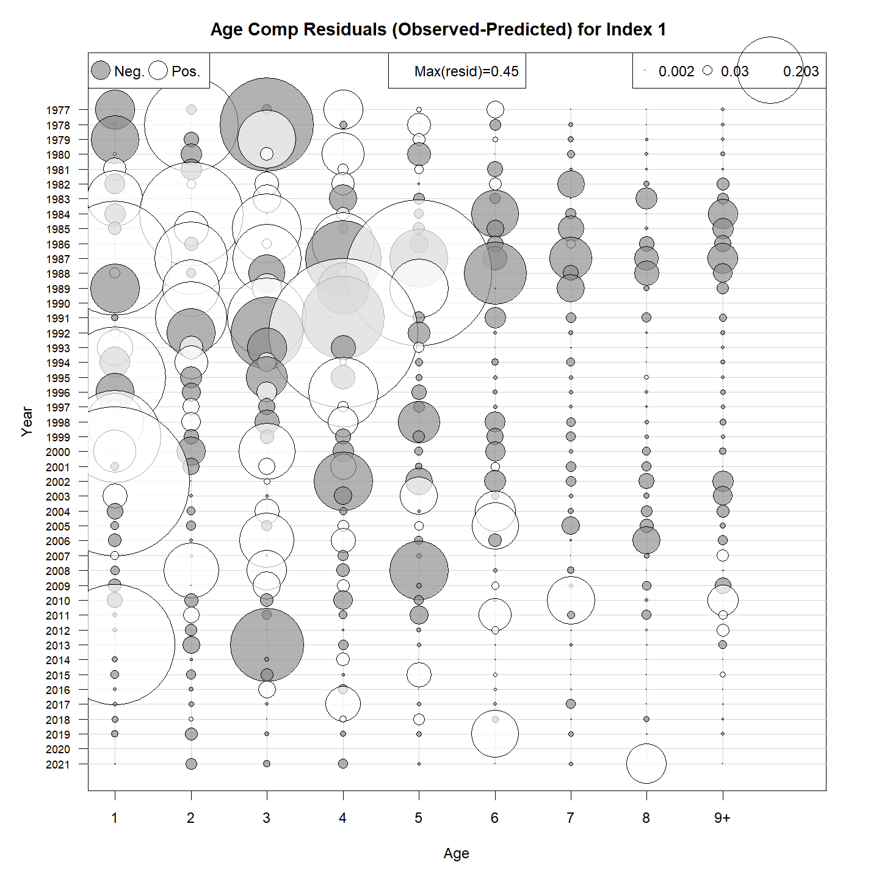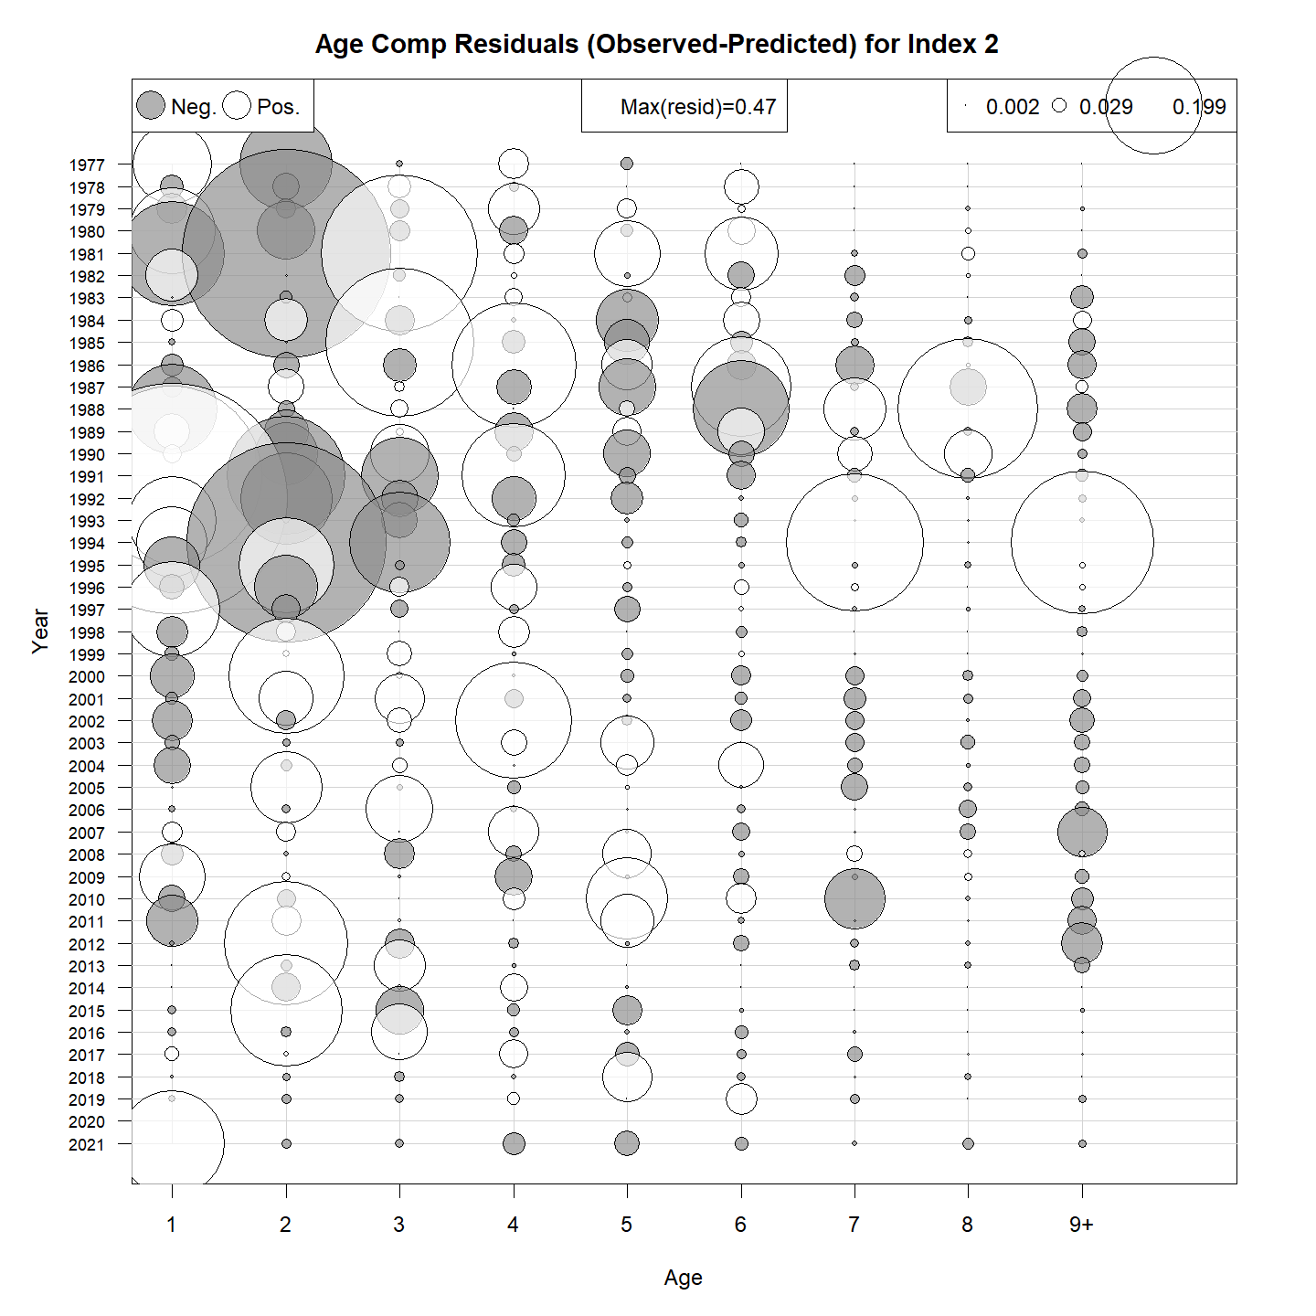

Figure 28. Age-composition raw residuals for the RE Dirichlet model. Fleet 1 is the combined fishery fleet, Index 1 is the NMFS spring survey, and Index 2 is the NMFS fall survey.

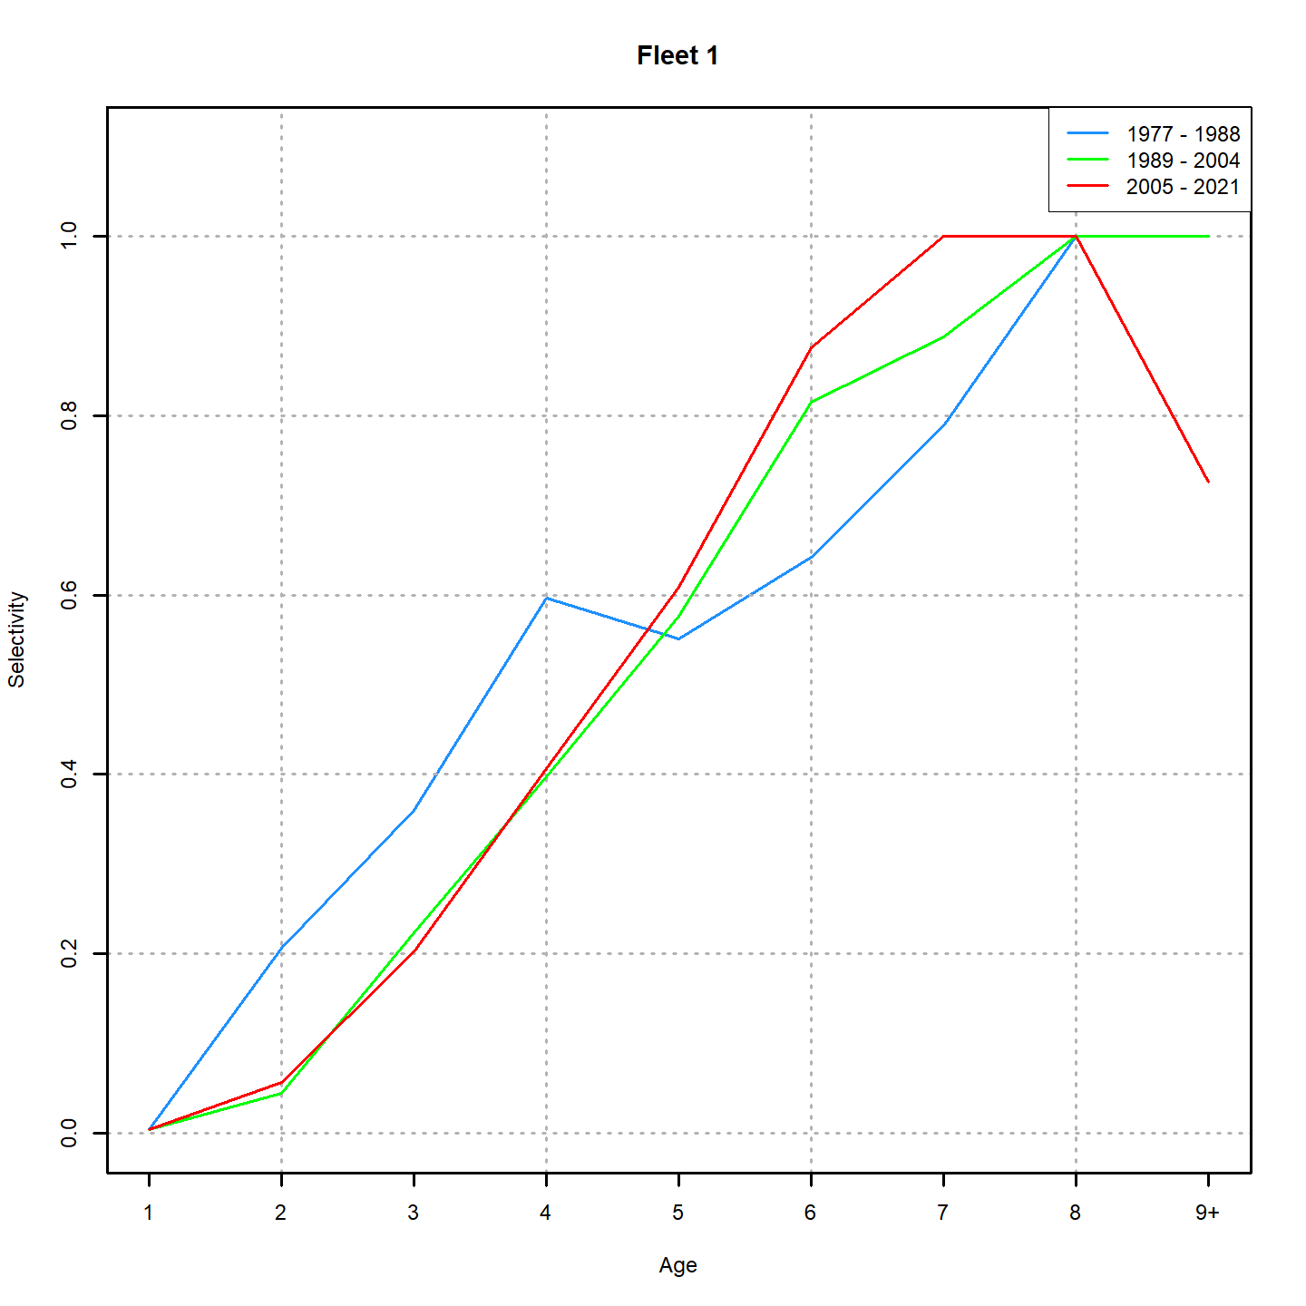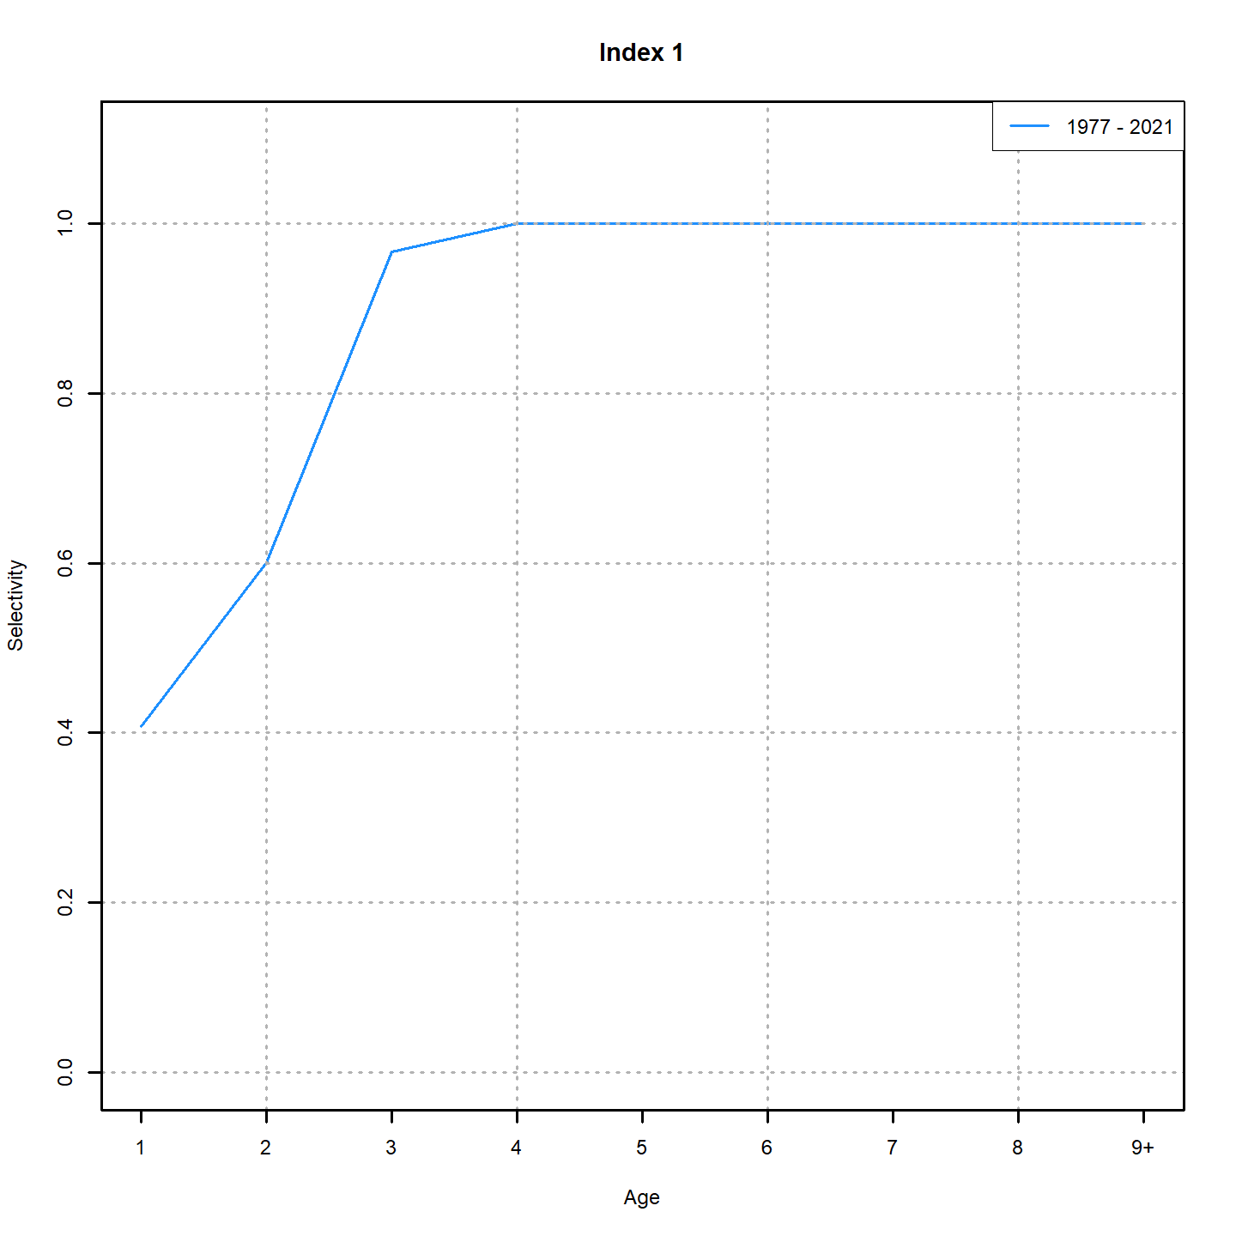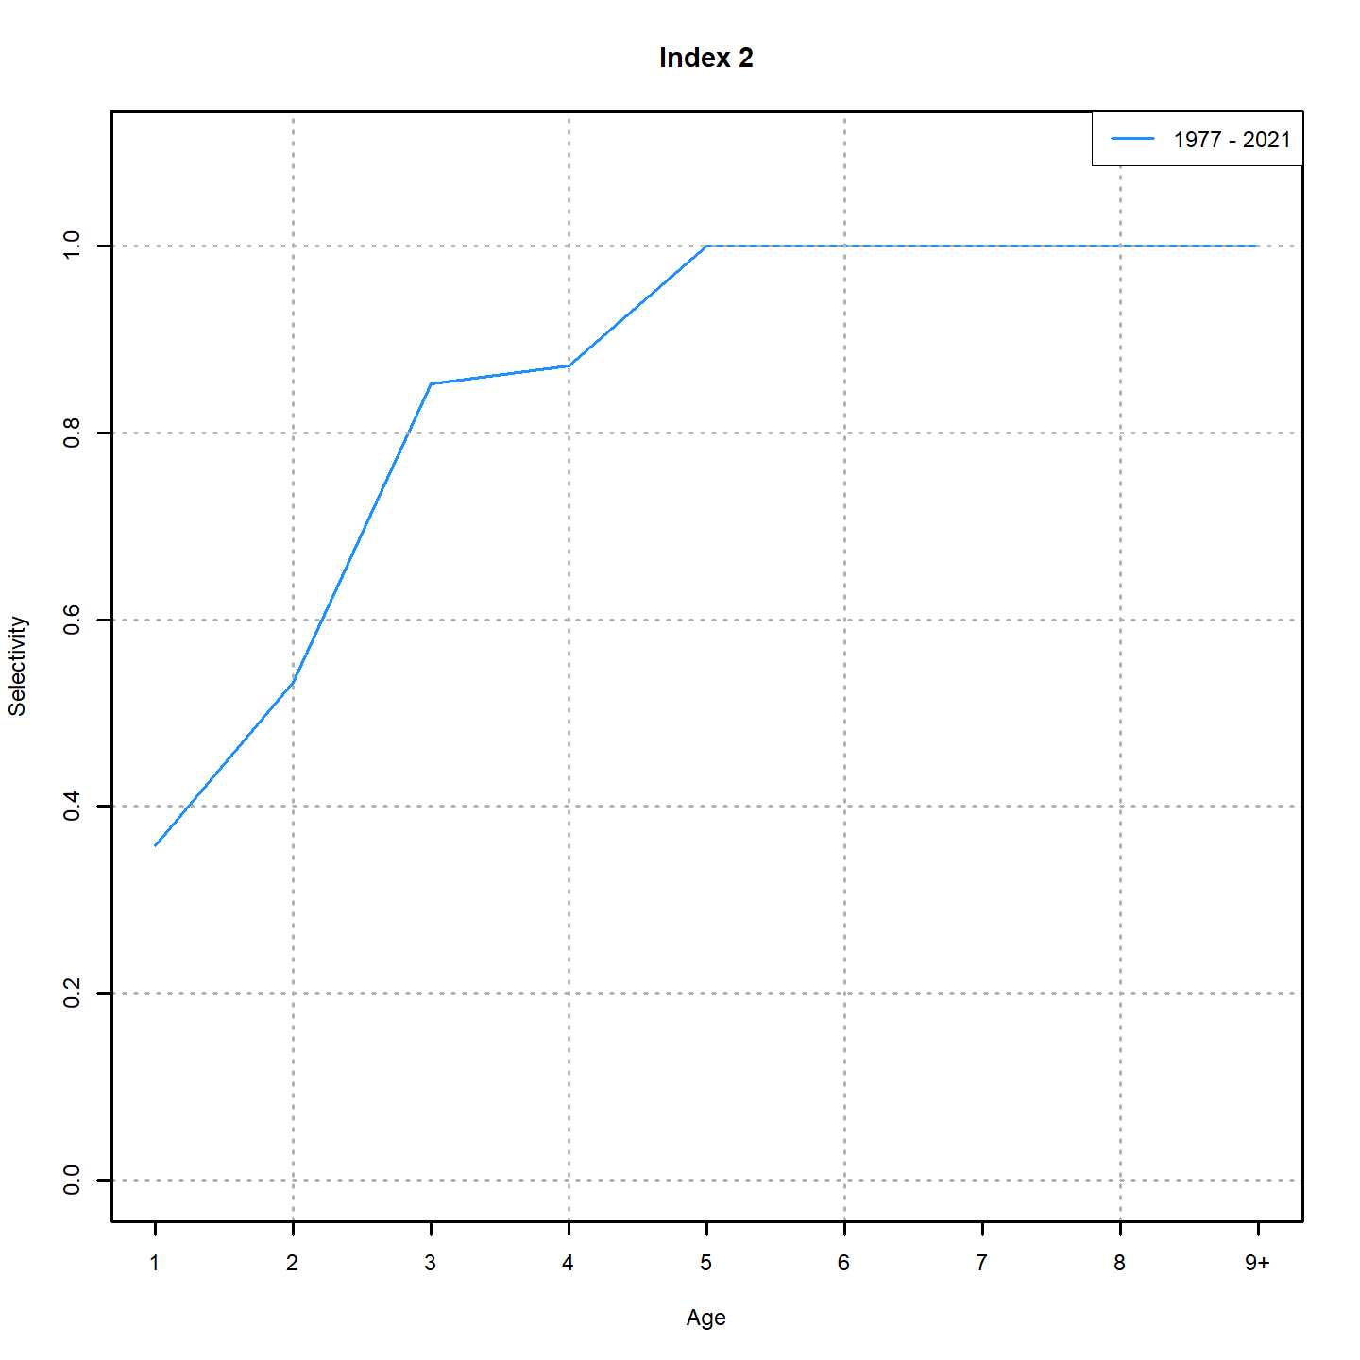

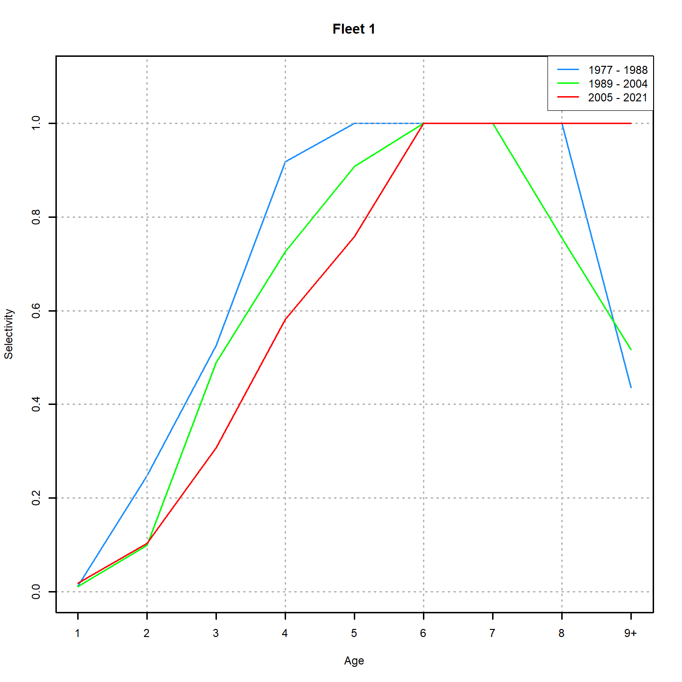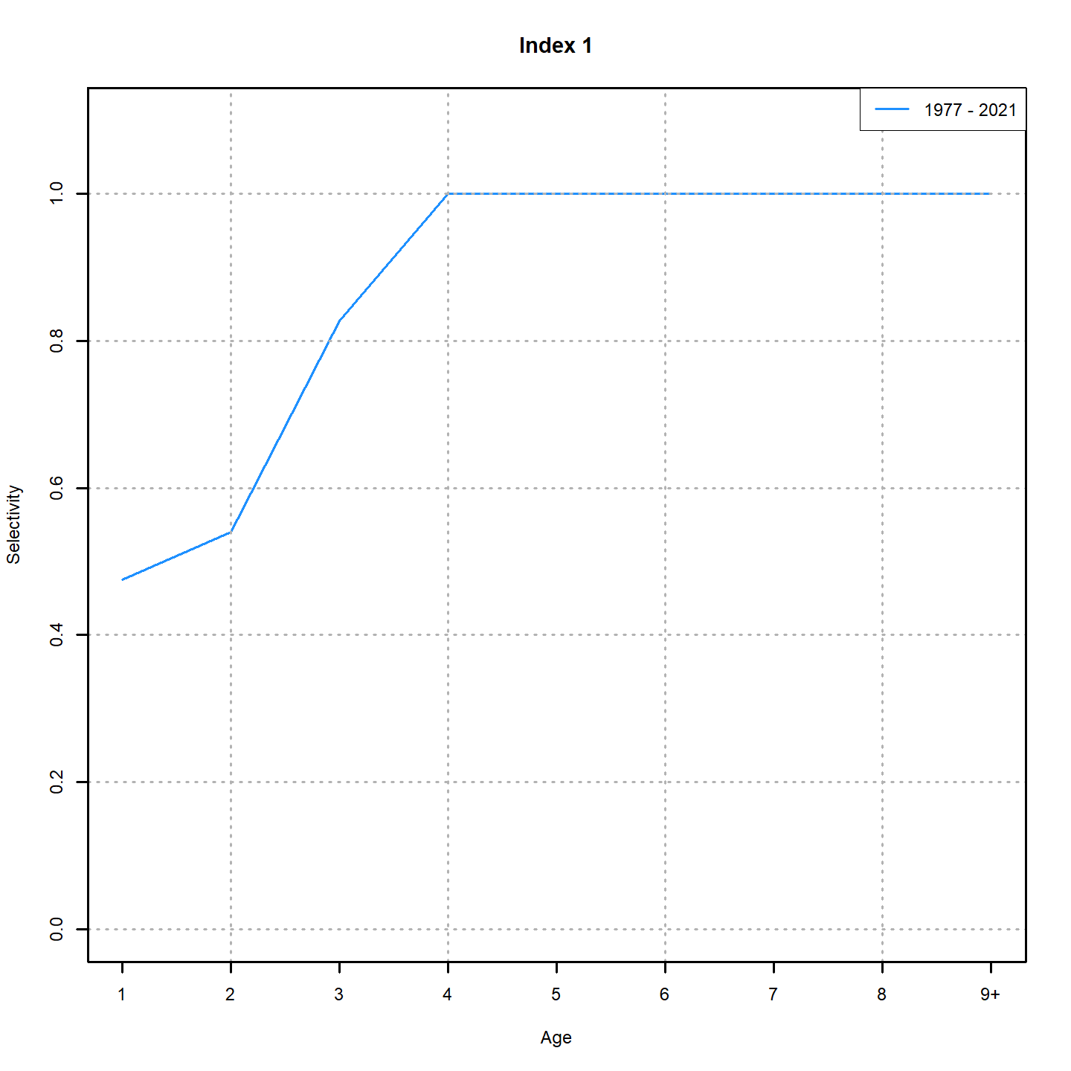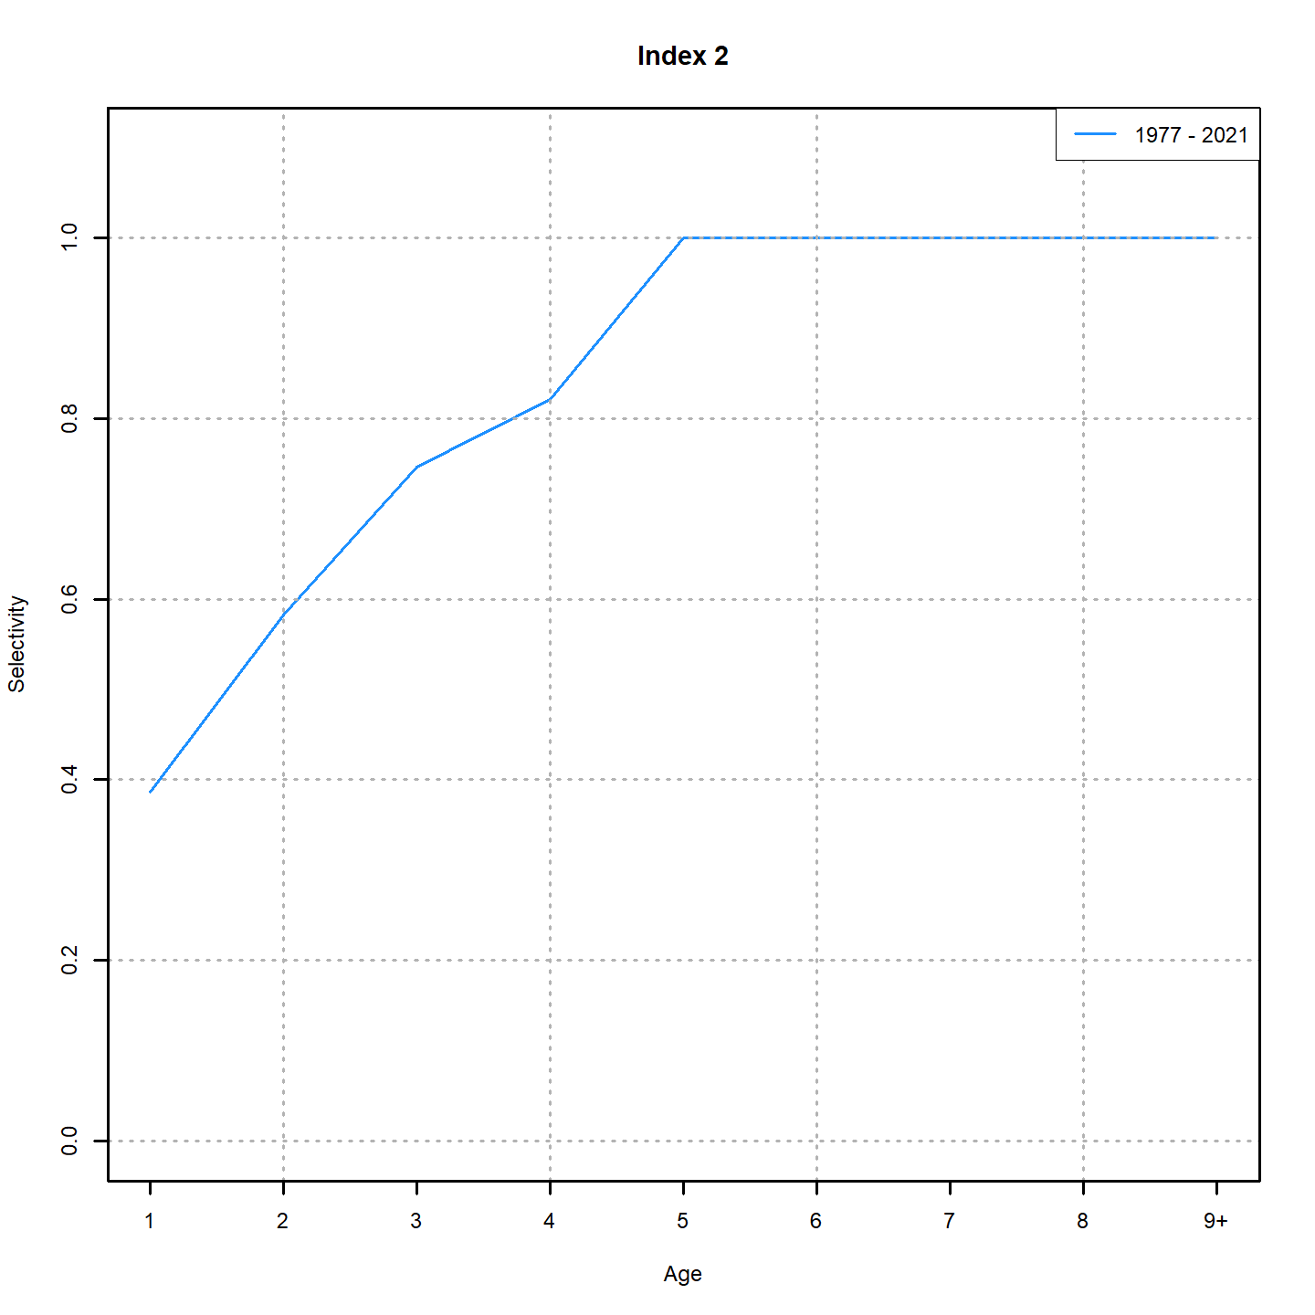

Figure 29. Comparison of selectivity estimates from the accepted ASAP model (top row) and the RE Dirichlet model (bottom row). Fleet 1 is the combined fishery fleet, Index 1 is the NMFS spring survey, and Index 2 is the NMFS fall survey.

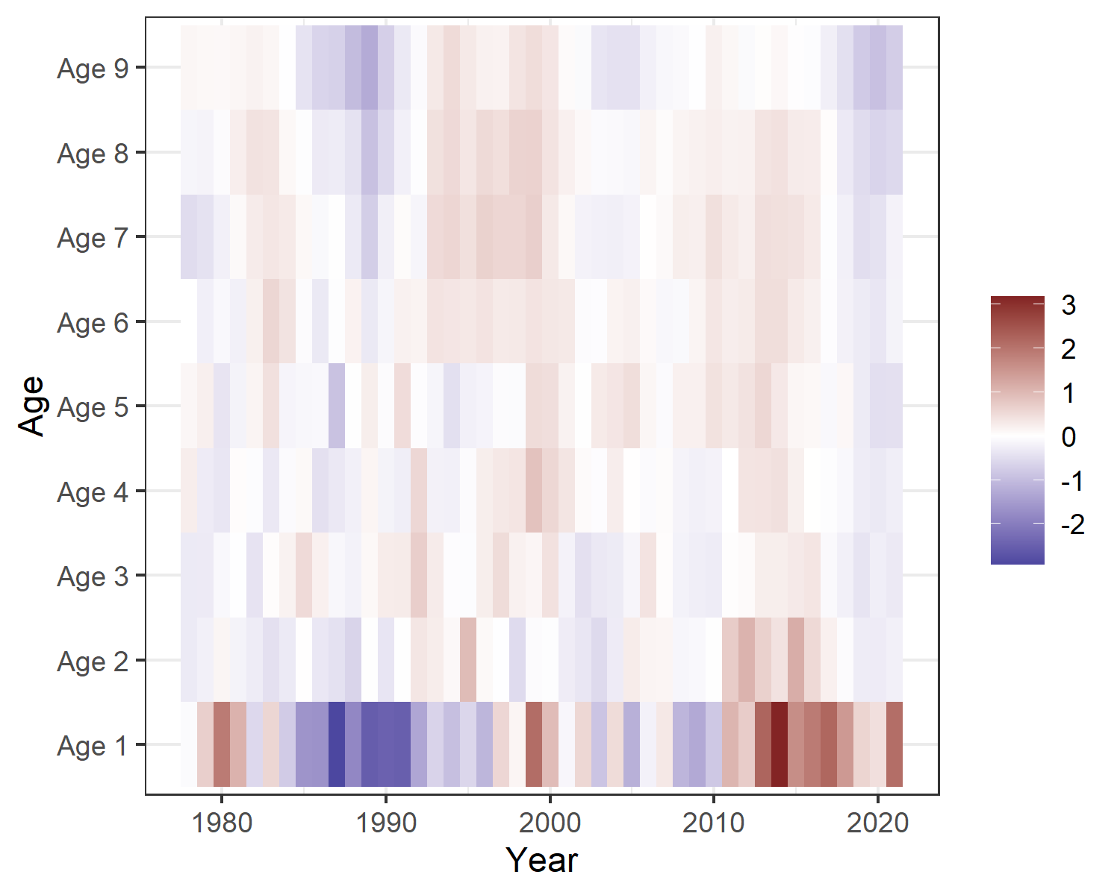

Figure 30. NAA random effect estimates from the RE Dirichlet model.

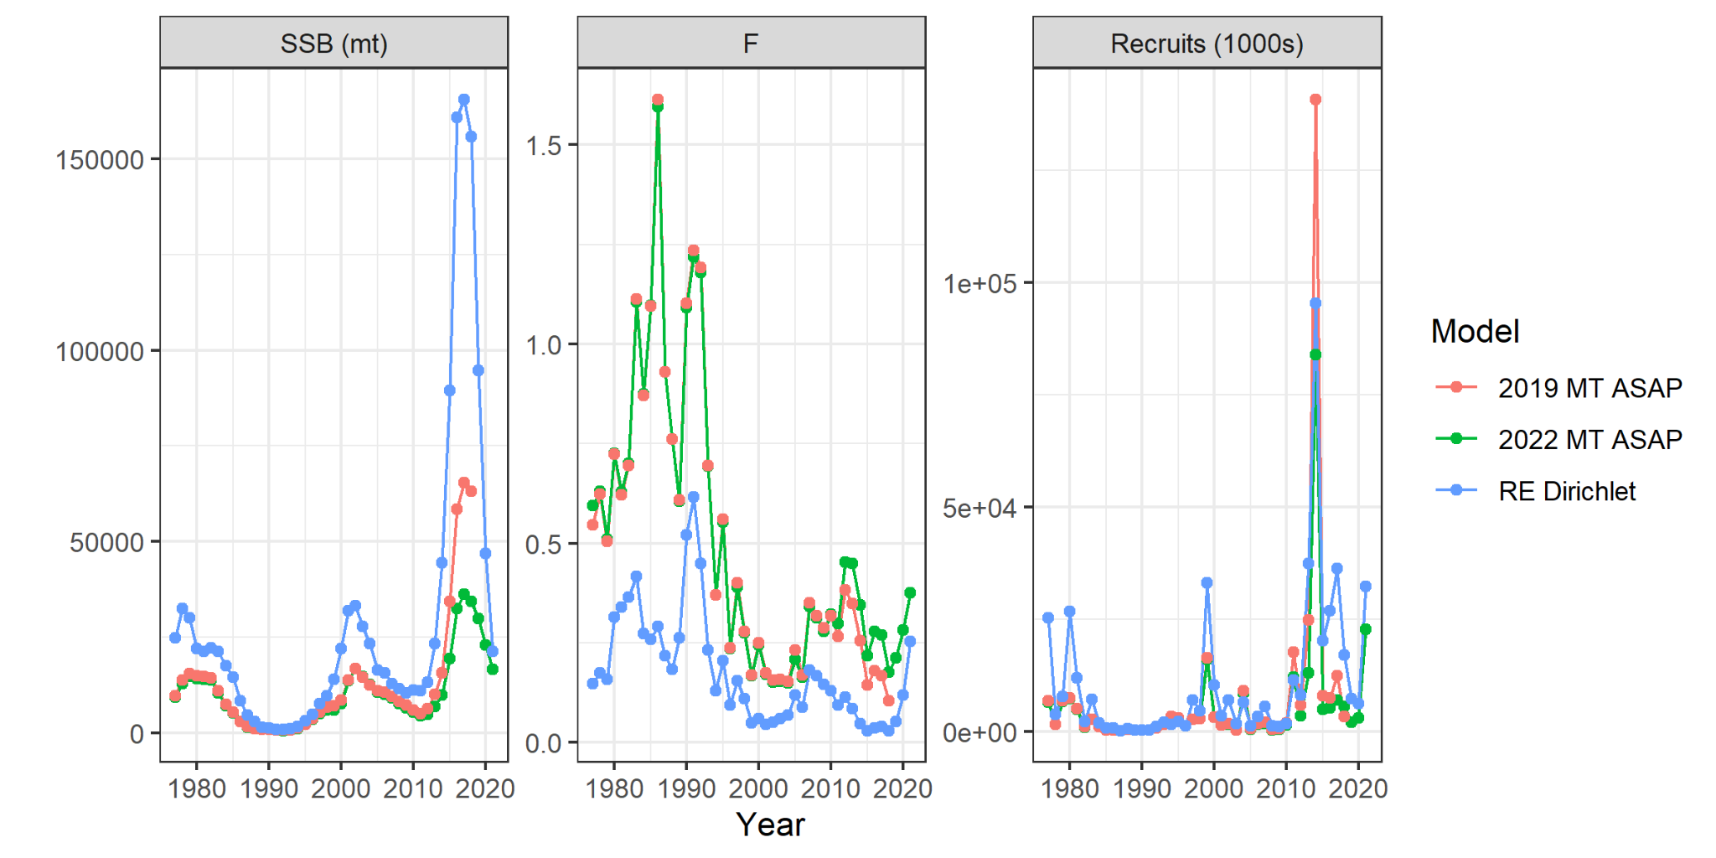

Figure 31. Comparison of SSB, *F*, and recruitment estimates from the accepted ASAP model from the past two Management Track assessments and the RE Dirichlet model.

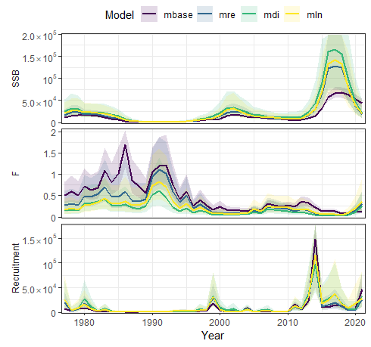

Figure 32. Comparison of SSB, *F*, and recruitment estimates from all WHAM model runs. Note that all RE runs show elevated SSB in the 2015 - 2020 time period compared to the ASAP-like (non-RE) run.

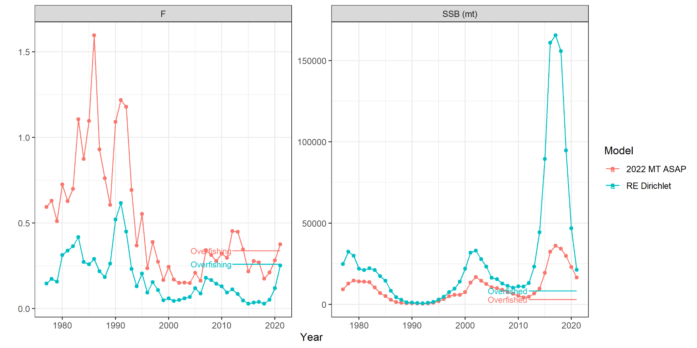

Figure 33. Comparison of *F* and SSB with the overfished (0.5*SSBmsy) and overfishing (Fmsy) thresholds from the RE Dirichlet model and the most recent Management Track assessment. Both models indicate the stock is overfished, while the RE Dirichlet model indicates *F* is just below the overfishing threshold.